New Delhi, India

Aug 16, 2023

Business Requirement Document

*Modern Statistics Platform (MauStats)*

**Revision History**

|  |  |  |  |
| --- | --- | --- | --- |
| Name | Date | Reasons of Changes | Version |
| iTM | 16th Aug 2023 | The first draft of BRD developed. | V1 |

1.0 Executive Summary 6

1.1 Document Convention 8

1.2 Intended Audience and Reading Suggestions 9

2.0 The System 11

2.1 Purpose of the System 11

2.2 System Overview and Scope 12

2.3 System Modules 15

2.4 System Security 18

2.5 Technology Stack 20

2.6 Web Hosting Requirements 21

3.0 Data Management 23

3.1 Data Schema 23

3.2 Geographical Coverage Entities 25

3.3 Access Control 27

3.4 Data Entry Methods 29

4.0 Functional Requirements 32

4.1 User Interface 32

4.1.1 Home 33

4.1.2 Explore Data 35

4.1.3 Gallery 43

4.1.4 Dashboards 45

4.1.5 Quick Data 46

4.1.6 Open API 47

4.1.7 Resources 49

4.1.8 About 50

4.1.9 Contact 50

4.2 Core Application 52

4.2.1 User Dashboard 54

4.2.2 Master Elements 55

4.2.3 Manage Classification 79

4.2.4 GIS 80

4.2.5 Access Control 83

4.2.6 Primary Dataset 85

4.2.7 Manage Survey 107

4.2.8 Resource 118

4.2.9 Customize 119

4.2.10 Reports 123

4.2.11 Language 127

4.2.12 SDMX 128

Annexure A: Data Dictionary 134

Annexure B: Data Flow Diagrams (DFD) 142

Level 0 142

Level 1: User Interface Application 143

Level 2: Core Application 144

Annexure C: System Architecture 145

Annexure D: Software Architecture 146

Annexure E: System Flow Charts 147

# 1.0 Executive Summary

Modernizing the business operations of Stat Mauritius (SM) is crucial to enhance efficiency, agility, and the overall effectiveness of statistical operations. The modernization is an ongoing process that requires a strategic approach, stakeholder engagement, and a focus on leveraging technology and data to drive efficiency and effectiveness. By embracing digital transformation, advanced analytics, automation, and user-centric design principles, SM will enhance their ability to provide accurate, timely, and relevant statistical information to support evidence-based decision-making and policy formulation.

To fulfill the objectives of modernizing the business operations and to align with Government of Mauritius Digital Transformation Strategy 2018 - 2022, SM is developing **Modern Statistics Platform (MauStats)** thatwill help to automate and integrate data lifecycle from acquisition to dissemination using Generic Statistical Business Process Model (GSBPM) framework.

This Business Requirement Document (BRD) provides system requirements specifications, system architecture design considering scalability, security, and integration needs, functional requirements, system flow, design user experience (UI/UX) for optimal usability, technology stack and infrastructure requirements and project plan outlining the timeline, milestones, and resources for the successful development and deployment of the platform.

The process of designing, developing and deploying the MauStats platform involves several stages and key steps. Various methods and tools will be used in all the stages to ensure the requirements of the project are met timely and accurately. The key tasks are –

* The requirements and objectives will be gathered through consultations with stakeholders to ensure that the platform aligns with user requirements and provides a valuable and intuitive user experience. Additionally, the industry best practices will be followed and adhered to relevant data protection and privacy regulations, and maintain ongoing collaboration with domain experts and data users to refine and enhance the platform's capabilities over time.
* Data migration strategy will be developed to consolidate and harmonize data from different sources. Data cleaning and validation processes will be implemented to ensure data quality. Data governance policies will be defined, including metadata management and data security measures.
* The backend infrastructure and a central database will be developed. The database will contain data gathered from the relevant data sources, including surveys, administrative records, and external data. Data processing and analysis algorithms will be developed to migrate the existing data with seamless data entry and validation. Application Programming Interface (APIs) or data connectors if available will be integrated for interoperability with external systems or data sources. The frontend components will be built, including the user interface and interactive visualizations for dissemination and use of data.
* The database will be able to store calculated/analytics results and processed data from new data sources. Customized data cleaning and data transformation functionalities will be developed. The data relationships will be maintained using MongoDB and customized data administration modules will be developed.
* Customized data exchange tools will be developed. Data will be mapped to the input files in XLS, CSV and other required formats. Data anomalies will be prevented through MongoDB integral structure.
* The platform will comply to manage data requirements for Census, SEE and SBR processed data in this phase. It will be feasible for data integration based on SM requirements.
* Thorough testing will be performed on the staging server to identify and fix any bugs or issues besides the functional testing to validate that the platform meets the defined requirements. Performance testing will be conducted to ensure the platform can handle the expected load and respond efficiently while security testing will be performed to identify and address vulnerabilities.
* Security Audit of the platform will be conducted to ensure the protection of sensitive data and identify potential vulnerabilities. This would include a comprehensive vulnerability assessment to identify weaknesses in the platform, conducting manual penetration testing to identify vulnerabilities, evaluate the platform's compliance with relevant data protection and privacy regulations among other assessment.
* Documentation will be developed including IT security policies, risk assessment and contingency plans.
* The platform will be deployed on the desired production infrastructure which will include configuring and optimizing the platform for performance and scalability. User Acceptance Testing (UAT) will be conducted to involve end users and gather feedback along with planning and executing a rollout strategy, ensuring a smooth transition from existing systems, if applicable.
* User and Admin training sessions will be planned and conducted to familiarize users with the platform's features and functionalities. User documentation and tutorials will be developed to support self-learning and a support mechanism will be established to address user queries, issues, and feedback.
* Monitoring tools will be setup to track the platform performance, data quality, and user activity. Technical support will be provided to regularly monitor and maintain the platform, applying updates, patches, and security enhancements. User feedback will be collected iteratively on the platform to address emerging needs and make continuous improvements.

## Document Convention

This BRD document follows global standards to ensure clarity, consistency, and effective communication. It will serve as general guidelines, and is adapted to suit this project and SM’s requirements. The standards followed to develop this document are well-structured and clear that effectively communicates the business requirements to stakeholders and project teams. This project will be managed using effective frameworks and proven methodologies such as AGILE and PRINCE2, to help increase the visibility, adaptability, alignment, product quality, business value and customer satisfaction. It will also help to decrease the risk of overtime and over budget. These methodologies will help to focus on delivering value in short cycles, known as sprints or iterations. Agile methodology embraces flexibility, adaptability, and collaboration, allowing for changing requirements and continuous improvement.

PRINCE2 (Projects in Controlled Environments) is a structured project management methodology widely used in government and large organizations. This methodology will provide a comprehensive framework with defined processes, roles, and documentation requirements, ensuring clear project governance.

## Intended Audience and Reading Suggestions

This document will be a ready reference for the audience who would be invoiced from project initiation to implementing and using the MauStats platform. This document comprises the platform overview, scope, modules, user flow and features with system design. This document is packed with visual diagrams depicting the features and functions of the platform to ease the understanding of each process. Data Flow Diagrams, Data Dictionary, System and Software Architecture, and System Flow charts are provided in this document. The following explains the audience groups, their expectations and reading suggestions of this document.

The project stakeholders that would include the Project Technical Committee would need to understand the overall objectives and how the project aligns with those goals. The system overview section of this document would help them understand the project's purpose, benefits, and high-level requirements. They can focus on that section that outline the business rationale, strategic alignment, and expected outcomes.

The project managers who are responsible for planning, coordinating, and executing the project would need to understand the project's scope, timeline, resource requirements, and potential risks. They should review the introduction section to gain an overview of the project's purpose, objectives, and scope. They should also focus on sections that outline project timelines, milestones, and deliverables detailed in Project Plan.

The design and development and testing teams need to understand the functional and technical requirements of the project to design and build the platform. They should focus on sections that provide detailed functional requirements, system specifications, data exchange, and technology stack. They may also refer to use cases and data flow diagrams for a better understanding of the system's behavior.

The quality assurance testing team need to understand the expected system behavior and acceptance criteria to create comprehensive test plans and ensure the solution meets the defined requirements. They should review sections that describe the acceptance criteria, expected outcomes, and any specific testing requirements or constraints. They can also refer to use cases and data flow diagrams to identify critical paths and test coverage.

The users of the platform will provide their valuable input to ensure the platform meets their needs. They should focus on sections that describe user requirements, workflows, core and user interface specifications. They can provide feedback on usability, user experience, and potential enhancements.

# 2.0 The System

## 2.1 Purpose of the System

SM business units are heavily dependent on excel and perform manual data cleansing and analysis, which results in operational inefficiencies and increases risk of compromising data integrity. Therefore, in order to bridge the gap, SM developed its e-Business Plan 2021-2024 with the objectives -

* To develop one stop data hub to improve user and stakeholder experience.
* Improving service delivery while adopting emerging technologies and modernizing its ICT operations.
* Achieving operational efficiency by eliminating duplicate and non-value-added tasks.
* Enhancing security and confidentiality across data life cycle.
* Adopting e-government principles and staying relevant with Government Digital Strategy.
* Becoming resilient, business as usual operations during crisis, disaster and pandemic situations.

The e-business plan suggests to develop MauStats platform as a web-based that will automate and integrate the data lifecycle from acquisition to dissemination. The platform will address the above objectives by providing a centralize data management, improving data quality assurance, streamlining data processing and analysis, enhancing data dissemination, promoting integration and collaboration, and ensuring compliance with international standards. The platform will aggregate and integrate data from diverse sources, including public datasets, surveys, and other relevant sources. It will provide mechanisms to ensure data quality, integrity, and version control. By providing a modern and intuitive user interface it will facilitate easy navigation, data exploration, and analysis where users will have access to interactive dashboards, customizable visualizations, and tools for filtering and querying datasets. Using the advanced analytical capabilities of the platform, users will be able to collect and validate data, perform complex calculations and aggregations, and generate meaningful insights from the data.

Data security and privacy will be paramount in the platform. It will incorporate robust security measures, including user authentication, data encryption, access controls, and compliance with relevant data protection regulations. The platform will be designed to handle large datasets and accommodate a growing user base. It will be scalable, ensuring that it can handle increased data volumes and user traffic without compromising performance. It will support integration with external systems by providing Open APIs for data exchange and following international Statistical Data and Metadata Exchange (SDMX) standards for data sharing. This will enhance and strengthen data ecosystems at national and sub-national level.

## 2.2 System Overview and Scope

The overall scope is to develop a modern statistical platform that will facilitate automation of end-to-end statistical processes hence resulting in operational effectiveness and efficiency. MauStats platform will allow SM to have an automated data lifecycle right from data acquisition up to dissemination. This will result as increase in efficiency in data operations, by overcoming fragmentation in tools, processes and data models, and enforcing a “quality by design”.

The platform will be developed using the open-source software technologies to ensure easy adaptability, usability, and scalability. The data will be stored centrally in a database to ensure consistency, security and accessibility. The design and development team will work closely under the guidance of SM team during the development and implementation cycle of the system. The platform will have role base access and to create and manage the underlying database and its elements. It will be designed to cater the needs of the key stakeholders. It will have responsive web design to support display on various screen sizes including that of computers, tablets, and mobile devices.

The platform will comprise of various modules and submodules to cater two groups of users. The first group of users are the SM staff and partners who have the critical role of managing and maintaining the platform by populating it with data. Second, are the viewers comprising of the line ministries, business partners, development practitioners cutting across government, private and other civil society organizations.

The platform will have the following features:

* Data management that involves handling, storing, processing, and securing the data generated by users or collected through various interactions on the platform.
* Managing roles and users to allow controlling user access, assigning appropriate permissions, and ensuring the security and integrity of the platform. Perform user authentication to verify the identity of users before granting access.
* Managing content to allow publishing datasets and access to primary data. Content management to enable users to create, publish, edit, and manage various types of content such as publications, reports, reference documents, articles and announcements.
* It will implement a search feature to allow users to easily find relevant data or results on the platform.
* The platform will provide administrators with insights into user behavior, platform usage, traffic, and other key metrics through analytics and reporting tools.
* There will be an admin dashboard to offer an intuitive and feature-rich interaction to manage users, content, settings, permissions, and monitor the overall platform performance.
* It will integrate with external services, APIs, or plugins to extend the platform's functionality.
* The platform will have multilingual support to cater to a diverse user base and enable localization of content and user interfaces.
* The design of the platform will be mobile responsiveness to ensure the platform is optimized for mobile devices, providing a seamless user experience across different screen sizes and operating systems.
* It will have security features to implement security measures such as encryption, secure authentication, access controls, secure coding practices, and regular security audits to protect user data and ensure platform integrity.
* There will be support system, including user guides and manuals, technical guidelines and documentation with training materials to assist users and address their queries or issues.
* The platform will provide the option of planning for data collection and allow users with appropriate permissions to manage their data entry plans, data validations and data aggregations.
* To secure data transmission between the web platform and other systems or third-party APIs using encryption protocols such as SSL/TLS. Implement secure API practices, including authentication, authorization, and input validation.
* To implement logging mechanisms to record important events and activities within the platform. Regularly review logs for security incidents and anomalies to detect and respond to potential threats.
* To stay up-to-date with data protection regulations and ensure compliance with relevant regulations. Establish processes to address user requests related to data access, correction, or deletion.
* To define roles and responsibilities, establish communication channels, and regularly test and manage the data security plan.
* To build capacity of SM staff on using and managing the platform, and their roles and responsibilities in protecting user data. Foster a culture of data privacy and security throughout the organization.
* To manage data using the admin modules to ensure data standardization and harmonization are followed that helps to maintain the security and integrity of user data. Collecting and entering data for their assigned datasets and only allow approved data to be published on the dashboard.

The platform is intended to attract the following stakeholders -

* General Public
* Private sectors
* Government ministries and institutions
* NGOs
* Regional and International organization such as UNDP, IMF etc.
* Data analysts and researchers

Furthermore, the platform will have -

* a responsive web application
* developed using open-source technologies
* managed by a centralized database
* scalable to manage master data
* cross-browser compatible
* multilingual support (English, French and Carole)

Additionally, the following tasks will be covered in this project -

* Training and capacity building with SM end users
* Technical and system administration training to SM IT team
* Develop technical documentation
* Develop test cases and user manual
* Maintenance and support

## 2.3 System Modules

Below is the list of the modules and their submodules of the platform. See **Annexure D: Data Flow Diagrams (DFD)** for input – process – output flow details of the platform and See **Annexure E: System Architecture** for interaction between modules.

The platform will comprise of the two main applications -

1. User Interface Application
2. Core Application

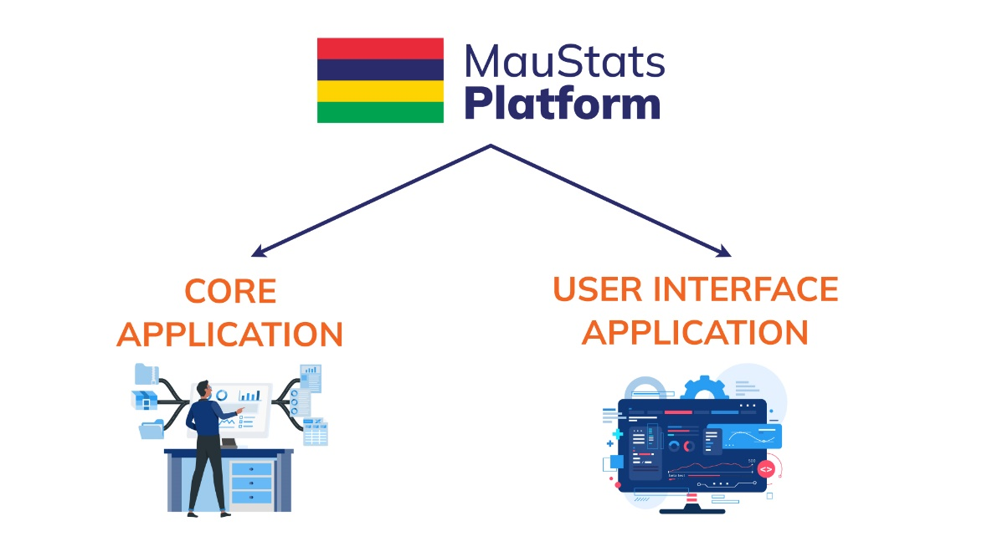Below diagram depicts the applications and their modules.

**User Interface**

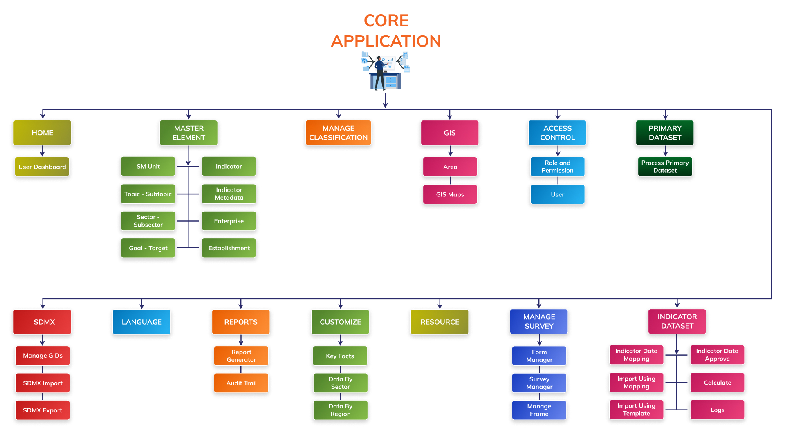**Core Application**

## 2.4 System Security

System security refers to the measures and practices implemented to protect the system and data from unauthorized access, damage, or disruption. It involves a combination of hardware, software, and procedural controls to ensure the confidentiality, integrity, and availability of information and resources. Below will be the security measures used in the platform:

* The platform will implement strong authentication mechanisms, such as multi-factor authentication (MFA), to ensure that users provide multiple forms of identification before accessing the system. This helps prevent unauthorized access even if passwords are compromised.
* There will be policies to keep operating systems, applications, and software up to date with the latest security patches and updates. Regularly applying patches will help to address known vulnerabilities and protects against exploits.
* The platform will enforce strong password policies, requiring users to create complex passwords that are regularly updated. Passwords should be unique, lengthy, and a combination of letters, numbers, and special characters.
* The platform will implement access controls based on the principle of least privilege, ensuring that users only have access to the resources necessary for their roles. Regularly review and revoke unnecessary privileges to minimize the risk of unauthorized access.
* The infrastructure to deploy the platform will segment networks into separate zones or subnets to isolate critical systems and restrict unauthorized access. This helps contain potential security breaches and limits lateral movement within the network.
* It is suggested to deploy firewalls to monitor and control incoming and outgoing network traffic. Configure firewalls to allow only necessary network connections and block unauthorized access attempts.
* It is suggested to install utilizes to detect intrusions to monitor network traffic and identify potential security threats or attacks. These utilities can detect and respond to malicious activities in real-time.
* The platform will implement encryption mechanisms to protect sensitive data both at rest and in transit. Encrypt data with encryption keys will secure the underlying datasets.
* There will be scripts implemented to regularly backup critical data and ensure backups are stored securely. Regularly test will be done to the restoration process to ensure data can be recovered in the event of data loss or system failure.
* It is suggested to conduct regular security awareness and training programs for the system administrator about security best practices, social engineering techniques, and the importance of safeguarding sensitive information.
* IT policies will be drafted to develop and maintain an incident response plan that outlines the steps to be taken in the event of a security incident or breach. This will include clear procedures for identifying, containing, investigating, and mitigating security incidents.
* Security Audit will be conducted identify vulnerabilities, evaluate existing security controls, and implement necessary improvements. This will help ensure that security measures are up to date and effective.
* IT policies will include implementing strict security measures when working with vendors and third-party providers. Ensure that they have appropriate security controls in place to protect sensitive data and access to systems.
* The system administrator will be implementing monitoring systems and logging mechanisms to capture and analyze system logs and network activities. There will be regularly review logs for suspicious activities and promptly respond to any security incidents.
* The production server will implement continuous security monitoring tools and processes to proactively detect and respond to security threats and vulnerabilities in real-time.

Furthermore, a IT security policy, IT contingency plan and IT risk assessment plan will be developed and submitted for review to finalize and implement. These security policy and plans will be tailored to the specific needs and risks of MauStats platform. Regularly review and updating security policies will be practiced to address emerging threats and maintaining an effective security posture.

The development process of the platform will ensure that all vulnerabilities of the web application will be identified and corrective measures will be taken to address them. The web application environment including the scripting language, web server software, and the recommended operating system are listed in the next section of this document. Configuration and coding will be done in the applications to manage the identified vulnerabilities. Manual testing will be conducted on the applications to ensure that no known vulnerabilities exist. Below are some of the known vulnerabilities that will be handled in the platform.

* Establishing and enforcing controls to restrict access to platform and sensitive data.
* Displaying the passwords between client and server in clear text
* Session hijacking
* Cross-site request forgery (CSRF) attack to load a page containing malicious request
* Upload malicious (.exe) file
* Brute force attack
* Not maintaining audit trails
* Runtime/Server error
* View the authenticated page from the cache of the browser
* Server version discloser in the header response
* Implementing regular data backups to ensure that critical information can be restored in case of data loss.

## 2.5 Technology Stack

The platform will be developed using the following environment and tools. See **Annexure E: Software Architecture.**

**Web Applications**

Operating Tool Ubuntu v20.04

Front-end Language JavaScript vES2015, HTML v5.0, CSS v3.0

Visualization Library ECharts v5.4, Leafletv1.9.3

Front-end Framework Angular v15

Back-end Language Node.js v18.10.0, PHP v7.2, Python v3.8

Back-end Framework Express v4.16.2, Laravel v8.11.2, Django v4.2

Database Tool Mongo DB v5.0, Redis v7.0, Hadoop v3.3, Hudi v0.13.1

Server Type Apache v2.4*, Docker v20.10.7, Docker composer v1.27.0

Data will be imported from Comma Separated Value (CSV files).

## 2.6 Web Hosting Requirements

**User Interfaces**

The user interface of the platform will be compatible with the commonly used internet browsers including Google Chrome, Mozilla Firefox, Internet Explorer and Apple Safari. The user interface will be developed using open-source software development technologies and frameworks.

The application will be easy to navigate and will have a menu-driven approach to access the modules based on the user roles and permissions.

**Hardware Interfaces**

The platform will be deployed either on a physical server or a web server. Internet or LAN connections will be required for the users to connect to the server.

**Software Interfaces**

The platform will be developed using open-source technologies that would allow easy extensibility and scalable communication Interfaces. The platform will use the HTTP protocol for communication over the internet.

The platform will need an internet connection to be deployed. It will be in the cloud on the Virtual Machines (VMs). The following recommended specifications those should be scalable.

|  |  |
| --- | --- |
| # of VMs | Purpose |
| 2 | To host the user interface and the core application (for staging and production) |
| 2 | To host the central database (for staging and production) |
| 1 | To host and manage the input files |

Each VM should have the following specifications:

Processor 8 vCPU

Memory 16 GB

Storage 500 GB SSD

Internet Connection 1 Gbps

Ports80, 27017, 6379

The cloud storage of 10 GB would be required to store all SM data. This shall be scalable to accommodate future needs.

Public IP and a dedicated domain is recommended to be used for the above deployment. SSL certificate will be required to enable encrypted communication between a web browser and a web server.

*Note: The above specifications are recommended requirements, though the platform will be able to be deployed on lower specification web-based instance with options of elastic storage and processor. Port 80 would be required only during the development process.*

# 3.0 Data Management

Multiple data sources are currently being used within SM for data collection, collation and dissemination. These data sources are categorised as Administrative Sources, Surveys and Census and others. Refer to Appendix A for data sources.

The current data size at SM is approximately 6 TB stored on the existing Core Statistics System and 500 GB for Survey Solutions among others. This Data Migration strategy will ensure that data existing in current SM servers are migrated to the MauStats central data repository.

The Data Migration Strategy will provide solutions to cater the transformation of data from the primary source to the MauStats central data repository. The overall steps to migrate the existing and further data will be to store the primary data as original in the compressed form by ingesting into the distributed storage system, distilling and cleansing the data using the defined business rules and processing the data for searching, reporting and analysing.

## 3.1 Data Schema

The central database will comprise of a normalized comprehensive data structure to capture the data. The data structure will outline the structure and organization of data within the database. It will define how data is stored, arranged, and related to each other. The data structure will store metadata that will include the location, format and size of primary data, data stage information, date/time stamp. types of data and the relationships between data entities. It will have the flexibility to accommodate various types of data without predefined structure.

Data will be stored in collections, and each document within a collection can have its own structure. This makes it suitable for storing unstructured or semi-structured data. Each document represents observation value or content. Each document will have a unique identifier and will store data as text, binary data, URLs, others, depending on the type of content.

Normalization principles will be applied to ensure data integrity and minimize redundancy. This will involve breaking down data into smaller, related tables to eliminate data duplication and anomalies.

Appropriate indexes will be created on fields that are frequently used in queries for improved performance. Constraints will be applied to maintain data integrity and enforce referential integrity between related tables, and unique constraints to prevent duplicate data. Appropriate data types will be used for each field to optimize storage and ensure accurate data representation. Techniques will be designed to support scalability, such as partitioning, sharding, and using NoSQL databases for specific use cases.

The primary data will be thoroughly analyzed and schemas will be designed to meet data storage, retrieval, and management needs effectively.

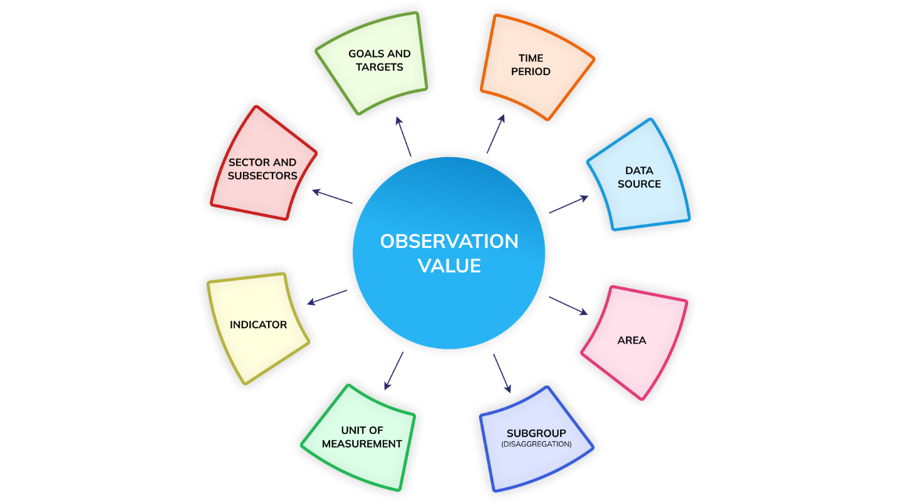In a typical scenario the statistical data will be considered as observation values, for example Population size, Number of people employed or Product price. Global standards will be followed to capture all the elements around the observation value. Below diagram explains the elements that defines the observation value.

Following provides a quick overview of these elements.

**Indicator**: A series of observations with harmonized characteristics representing a standard behavior. Example Population size.

**Unit of Measurement**: Measurement scale of the observation values. Example Percent, Number.

**Subgroup**: Disaggregated group to represent further dimensions of the observation. Example Sex, Age.

**Goal/Targets** Termed as Indicator Classification that groups similar indicators for organized storage and reporting.

**Sector/Sub-sector**: Termed as Indicator Classification that groups the similar indicators and organize them in categories and subcategories.

**Area**: Geographical or administrative boundaries to represent the data values.

**Time Period**: The reported time period associated with the data values for each IUS (Indicator-Unit-Subgroup) combination.

**Data Source**: The data source from which the reported data values for each IUS combination Will be obtained.

## 3.2 Geographical Coverage Entities

The platform will be developed to store and manage data at various geographical levels or administrative boundaries. The geographical level will be termed as Area. The admin modules will have features to manage Areas and their geo-spatial maps. The platform will be capable to manage the area at following level -

* National - This level pertains to the entire country of Mauritius. The platform will accommodate data storage and management for statistical indicators at the national level.
* Sub-national - At this level, the platform will allow for data management at smaller regional or sub-national levels within Mauritius. It will support the storage and organization of statistical data specific to different regions, districts, or local administrative units.

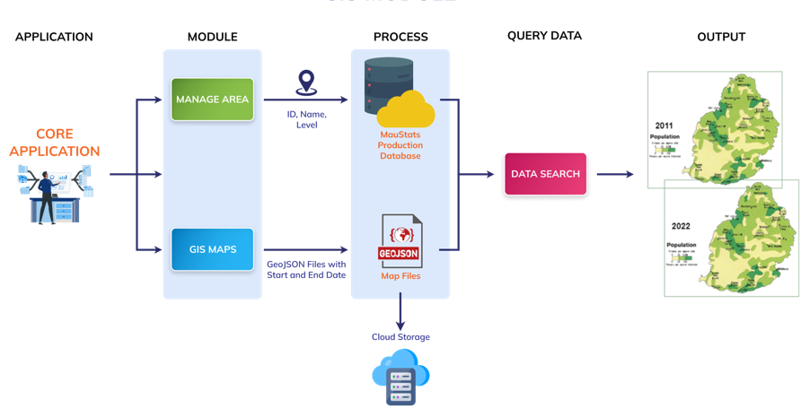This will enable efficient data handling and analysis at both the national and sub-national levels, ensuring that information is appropriately organized and accessible according to the geographical context. As explained in the data structure section the data values will have an area dimension which will refer to the geographical area for which the data is entered. The area dimension will help in data analysis and comparison at all geographical levels of various datasets. Below diagram explains the structure and steps to manage and store GIS data.

The system administrator and users with appropriate permissions will be able to manage area and their GIS maps. The diagram provided above illustrates the processes and actions to understand the use of areas and GIS maps within the platform. The admin/authorized user will be able to import/add areas using the Manage Area module and import the respective GIS map files of the area using the Manage GIS Maps module. Each area will have the following details –

* Area ID
* Area name
* Area Level
* Area Parent ID

For each area entered/imported there will be map associated. Area ID will be the common key between the area master and the related maps. One or more maps can be related to one area id to manage the chorological maps of same area which may have changed due to area split or merge. One or more maps associated to the same area will be distinguished by having a different start and end date for each shape. The maps will be managed in GeoJSON format file and will be stored in the application server. Users will be able to search and view the data in thematic maps based on the selected area and time period.

## 3.3 Access Control

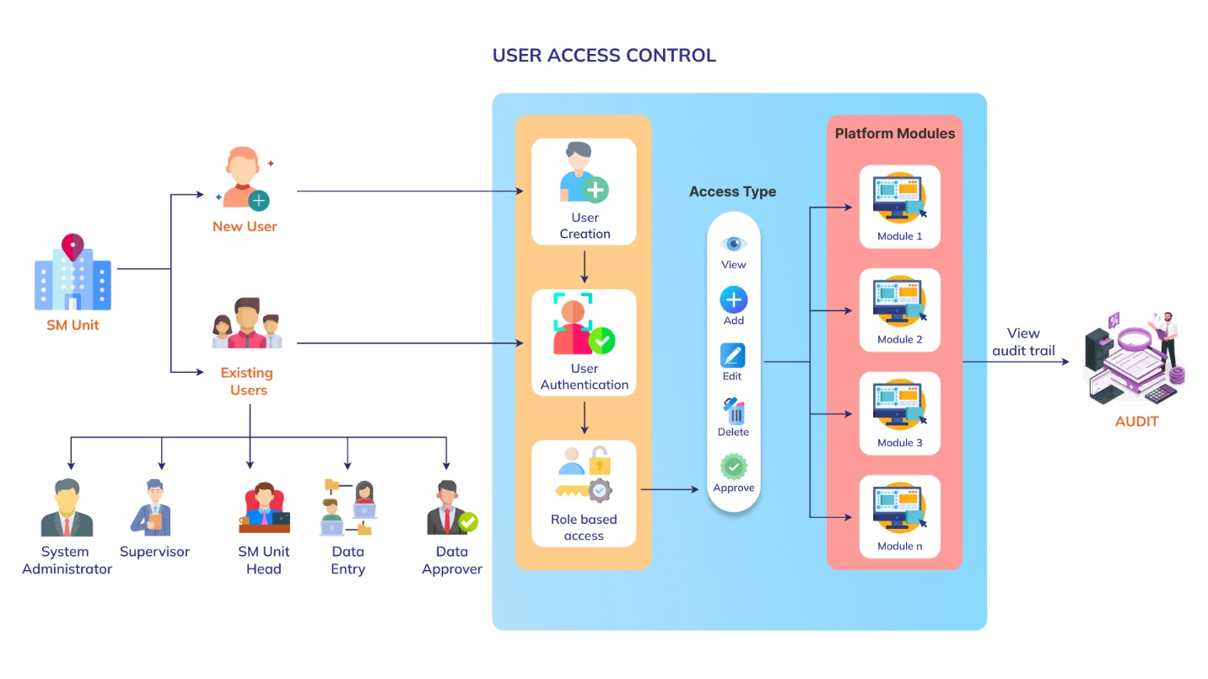The platform will have a role-based access to the various modules. The admin will be allowed to create and manage roles, assign modules and set permissions to the roles to access the MauStats platform. By default, five roles will be created in the platform which are explained below. The users of the platform will be responsible to enter and approve data for their assigned indicators and geographical areas. These users will login with their respective credentials. While the data entry user will enter data for their assigned indicator and area, the data approval user will check and mark the data as approved or reject data and enter remark for rejection. For the rejected data, the data entry user will be able to edit and re-submit the corrected data for approval. The approved data will be published and viewed in the user interface modules of the platform. Below diagram depicts the access control of the MauStats platform.

The diagram provided above illustrates the access control mechanism in the platform. It depicts that how a user can access the MauStats platform and view the various modules. The existing users can log in directly using their valid login credentials, while new users need to request access. The administrator will create new user accounts on the platform and assign them specific roles. Each role will have various set of permissions to perform in the platform. The users’ details will be stored in the central database. User will be required to enter their email and password to login in the data manage application and the credentials will be authenticated in the backend to allow only authorized users to access the platform. Once the login credentials are authenticated, user will be able to login into the platform and can access the assigned modules.

Following will be the type of users in the platform -

1. Administrator
2. Supervisor
3. SM Unit Head
4. Data Entry
5. Data Approve

**Administrator**

There will be a pre-created user with super administration rights that will have access to all the modules of the platform. The system administrator will be able to create and further users and assign them roles.

**Supervisor**

This user will be created by admin and will be able to create and manage plans. The supervisor will be allowed to create, edit, delete and show/hide the plans they have created.

**SM Unit Head**

This user will be created and managed by admin and will be assigned a SM Unit(s). The SM Unit head will have access to all the modules of the platform same as administrator but only be able to allowed enter/approve data for their assigned unit.

**Data Entry**

Data Entry users will be allowed to import or enter data of their assigned indicators and areas. They will also be allowed to edit and manage the data they have entered.

**Data Approver**

Data Approver users will be allowed to view, approve or reject the data entered by the data entry users. They will be able approve data of their assigned indicators and areas.

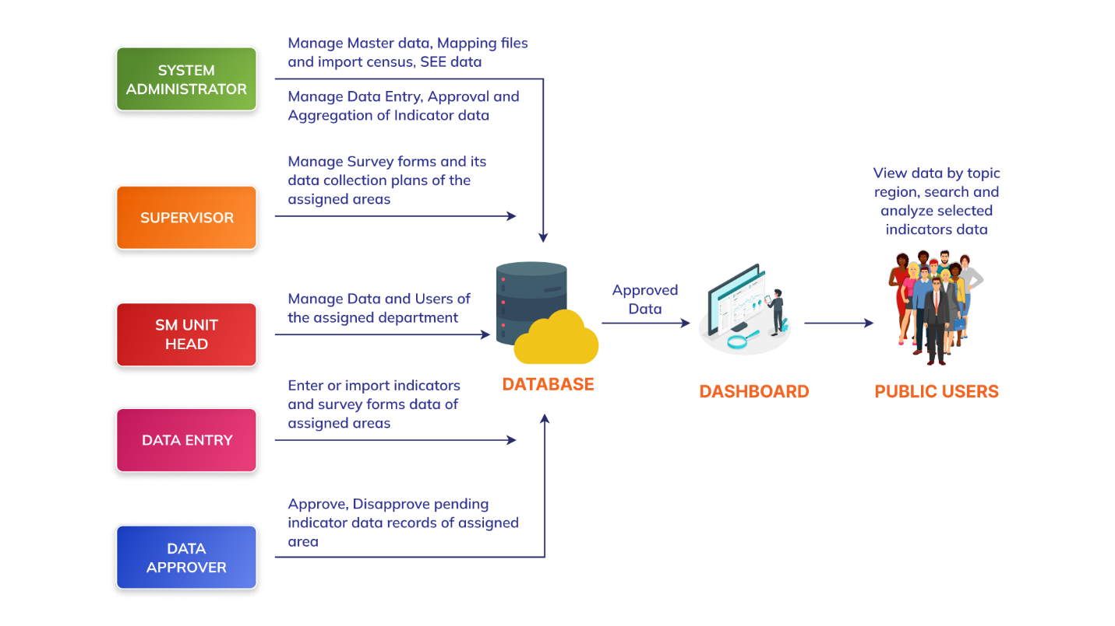Below is the user roles diagram -

## 3.4 Data Entry Methods

To implement user-friendly data entry process various data entry methods will be developed. Below is the detailed explanation of the data entry methods -

**Offline Data Entry**

To allow bulk data entry, a user-friendly data entry template will be developed. Data entry users will be able to download these templates (CSV file format). The CSV file can be opened and edited using spreadsheet software such as Microsoft Excel or Google Sheets. Data can be entered offline into the CSV file and imported into the database. An import log will be generated to track the data entry.

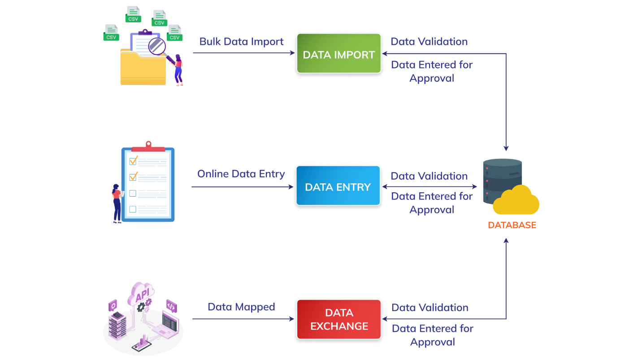By providing a user-friendly data entry template and generating an import log, the bulk data entry process will become more efficient, reduce manual data entry efforts, and will enable offline data entry with subsequent integration into the database system.

**Online Data Entry**

In addition to the offline bulk data entry option using CSV files, an online data entry process will be used to allow users to enter data interactively in a data grid format. This method provides a user-friendly and real-time data entry experience. As user will enter data, real-time validation checks will be performed to ensure data integrity and adherence to predefined rules. For example, the platform will validate data types, field lengths and mandatory fields to maintain data quality. User will also have the option to edit and delete the data record.

This method will offer a convenient and efficient way to input data, perform real-time validations, and maintain data accuracy.

**Data Entry using APIs**

For indictors where data has to be pulled from other existing platforms and where Application Programming Interface (APIs) are available to be consumed, the platform will integrate the APIs and would import data in real time. The development team will integrate the APIs provided by the external platforms from which data needs to be pulled. This will involve establishing a connection between the platform and the external APIs, using authentication credentials or API keys provided by the external platforms. Using the integrated APIs, the platform will send requests to the external platforms to fetch the required data. The external platforms will respond to the API requests with the requested data.

# 4.0 Functional Requirements

## 4.1 User Interface

The User Interface application will comprise of the following modules and submodules -

1. Home

* Login

1. Explore Data

* Data by Sector
* Data by Region
* Search Data
* Data by Topic

1. Dashboards

* Published Dashboards
* Manage Dashboards

1. Gallery

* Published Galleries
* Manage Gallery

1. Quick Data
2. Open API
3. Resources
4. About
5. Contact

Below is the brief description and functionalities of each of the user interface modules.

### 4.1.1 Home

**Description**

This module will be the landing page of the platform and can be accessed by public users. The performance of selected key indicators will be presented here and will also have options to navigate to other modules of the platform. Home page will have login option to allow users to enter their credentials and get access to modules which are under login based on their roles and permissions assigned to them by the administrator. Below mentioned is the functionality requirement of this module.

**Functional Requirements**

|  |  |
| --- | --- |
| REQ 1 | Show the platform logo at the top left corner of the home page. |
| REQ 2 | Show the language option at the top right corner of the home page. |
| REQ 3 | Show the user icon to the right side of the language option. |
| REQ 4 | Show a burger menu to the right side of the user icon and allow navigating to the other modules. |
| REQ 5 | Show dynamic key facts along with a background image as sliders in the first section of the home page. Show 6 sliders with dynamic key facts navigated by dots. |
| REQ 6 | Show brief summary about the MauStats platform in the second section of the home page. |
| REQ 7 | Show Statistics by Subject’s information in the third section of the home page |
| REQ 7 | Show three latest news in the fourth section of the home page and provide following information with each -   * An associated Image * Date * Title |
| REQ 8 | Show the MauStats platform logo to the left side in the footer section. |
| REQ 9 | Show following navigation menu to the right side of the footer – Home, About Us, Resource and Contact Us. |
| REQ 10 | Show copyright message below the platform logo and iTM below the navigation menu. |

#### Login

**Description**

The users of the platform will be created and managed by the system administrator. The core application, along with selected modules of the user interface, can be accessed through the login process. The users with valid login credentials will be allowed to access these modules. Below is the detailed functionality requirement of the login panel.

**Functional Requirements**

|  |  |
| --- | --- |
| REQ 1 | The system administrator will be able to login by using pre-created email ID and password. |
| REQ 2 | Provide option to access login panel |
| REQ 3 | Provide option to enter email Id and Password. |
| REQ 4 | Provide option to enter a captcha for security measure. |
| REQ 5 | Provide a login button to confirm the login process. |
| REQ 6 | Show error message when invalid email ID or password is entered. |
| REQ 7 | The login button should not be enabled until the entered captcha matches the system generated captcha. |
| REQ 8 | Provide option to reset password in case the users have forgotten their password. |

### 4.1.2 Explore Data

This module will comprise four submodules - Data by Sector, Data by Region, Search Data and Data by Topic. Below is the brief description and functionality requirements of these submodule. -

#### Data by Sector

**Description**

This submodule will present the national data by sector and associated subsectors. It will allow focused analysis of data within specific sector and its subsectors and enables comparisons, trend identification, and deeper insights into sector-specific performance using visualizations.

**Functional Requirements**

|  |  |
| --- | --- |
| REQ 1 | Show the module logo at the top left corner of the page. |
| REQ 2 | Show the language option at the top right corner of the page. |
| REQ 3 | Show the user icon to the right side of the language option. |
| REQ 4 | Show a burger menu to the right side of the user icon and allow navigating to the other modules. |
| REQ 5 | Show Data by Sector option highlighted when user navigate to this submodule. |
| REQ 6 | Show the list of sectors, subsectors and associated indicators to the left side of page and show the selected option highlighted. |
| REQ 7 | Show the selected sector as header along with a brief description to the right side of the page. |
| REQ 8 | Provide a key fact and brief description related to the key fact below the header. |
| REQ 9 | Show selected indicators data to the left side of the key fact using visualization in case one indicator is selected. Provide following options to select in the widget –   * Disaggregation * Time Period   Show source of the data at the bottom of each widget. |
| REQ 10 | Show six indicators’ data each in separate widgets to the left side of the key fact in case any topic or subsector is selected. |
| REQ 11 | Show burger menu in each widget and provide the following options to perform on the data -   * Line Chart * Bar Chart * Column Chart * Area Chart * Tree View * Table * Map * Label on/off * Legend show/hide * Swap * Download * Expand * Share |
| REQ 12 | Show a compare button to the top right corner incase single indicator is selected. |
| REQ 13 | Show a plus button to the right side of the widget when user clicks on compare button. |
| REQ 14 | Open a pop-up window and show the list of indicators by sector when clicking on the pus button. Allow to search indicators and select one of the indicators to compare to the currently selected indicator. |
| REQ 15 | Show comparison of both the indicators in separate widget with following options to select -   * Disaggregation * Time period   Show source of the data at the bottom of each widget. |
| REQ 16 | Show burger menu in both the widget and provide the following options to perform on the data-   * Line Chart * Bar Chart * Column Chart * Area Chart * Tree View * Table * Map * Label on/off * Legend show/hide * Swap * Download * Expand * Share |
| REQ 17 | Show information icon with the name of the indicator clicking on which show the indicator’s metadata. |

#### Data by Region

**Description**

As the name suggests, the data by region submodule will present the data by selected region. This submodule will allow regional analysis of data, enabling comparisons, identifying patterns, and gaining insights specific to selected geographic locations.

**Functional Requirements**

|  |  |
| --- | --- |
| REQ 1 | Show the module logo at the top left corner of the page. |
| REQ 2 | Show the language option at the top right corner of the page. |
| REQ 3 | Show the user icon to the right side of the language option. |
| REQ 4 | Show a burger menu to the right side of the user icon and allow navigating to the other modules. |
| REQ 5 | Show the area dropdown when hovering on the Data by region option and allow selecting one. Highlight the menu option when user navigates to this submodule. |
| REQ 5 | Show Data by Region option highlighted when user navigate to this submodule. |
| REQ 6 | Show the list of sectors, subsectors and associated indicators to the left side of page and show the selected option highlighted. |
| REQ 7 | Show the selected area name as header along with the selected sector name and a brief description about it to the right side of the page. |
| REQ 8 | Provide a key fact and brief description related to the key fact below the header. |
| REQ 9 | Show selected indicators data to the left side of the key fact using visualization in case one indicator is selected. Provide following options to select in the widget –   * Disaggregation * Time Period   Show source of the data at the bottom of each widget. |
| REQ 10 | Show six indicators’ data each in separate widgets to the left side of the key fact in case any sector or subsector is selected. |
| REQ 11 | Show burger menu in each widget and provide the following options to perform on the data -   * Line Chart * Bar Chart * Column Chart * Area Chart * Tree View * Table * Map * Label on/off * Legend show/hide * Swap * Download * Expand * Share |
| REQ 12 | Show a compare button to the top right corner incase single indicator is selected. |
| REQ 13 | Show a plus button to the right side of the widget when user clicks on compare button. |
| REQ 14 | Open a pop-up window and show the list of indicators by sectors when clicking on the plus button. Allow to search indicators and select one of the indicators to compare to the currently selected indicator. |
| REQ 15 | Show comparison of both the indicators in separate widget with following options to select -   * Disaggregation * Time period   Show source of the data at the bottom of each widget. |
| REQ 16 | Show burger menu in both the widget and provide the following options to perform on the data-   * Line Chart * Bar Chart * Column Chart * Area Chart * Tree View * Table * Map * Label on/off * Legend show/hide * Swap * Download * Expand * Share |
| REQ 17 | Show information icon with the name of the indicator clicking on which show the indicator’s metadata. |

#### Search Data

This module will allow users to search, view and select indicators grouped by datasets to create powerful visualization using the searched result. This submodule will have option to present data using various visualizations like table, charts, and thematic map. You will be able to download the data in different formats and share the visualizations.

**Functional Requirements**

|  |  |
| --- | --- |
| REQ 1 | Show the module logo at the top left corner of the page. |
| REQ 2 | Show the language option at the top right corner of the page. |
| REQ 3 | Show the user icon to the right side of the language option. |
| REQ 4 | Show a burger menu to the right side of the user icon and allow navigating to the other modules. |
| REQ 5 | Provide option to Select & Visualize data or Explore & Visualize in the center of the page. |
| REQ 6 | Incase Select & Visualize is selected, provide option to search and indicator and geographic area. Allow selecting multiple indicator(s) and area(s). |
| REQ 7 | Provide a search button clicking on which user should be able to view data of the selected indicator(s) and area(s). |
| REQ 8 | Incase Explore & Visualize is selected, show four tabs and provide the option to select Dataset, Area and Indicator in the first three tabs. Allow selecting multiple indicator(s) and area(s). |
| REQ 9 | Show those datasets enabled for which the data exists. Show the other two elements (Area and Indicator) enabled if the data exist for the selected dataset. Rest option will be disabled. |
| REQ 10 | Show the fourth tab as View Data clicking on which show the selected parameters data in tabular grid. |
| REQ 11 | Provide a next button at the bottom to move forward and backward between the four tabs. |
| REQ 12 | Show the selected parameters below the next button. |
| REQ 13 | Provide a reset button at the top right corner of the page to clear the selected options. |
| REQ 14 | Show the selected data in tabular grid which checkbox with each record. Show the following columns of the table grid-   * Dataset * Area * Indicator * Time period * Data Value * Source   Allow selecting the records using the checkbox. |
| REQ 15 | Show the following visualization option in the second section-   * Line Chart * Column Chart * Bar Chart * Pie Chart * Donut Chart * Bubble Chart * Map * Area Chart |
| REQ 16 | Enable the visualization options when at least one record is selected and allowing viewing the selected data in the required visualization. |
| REQ 17 | Show the source of the data at the bottom of the visualization. |
| REQ 18 | Provide the option to download the visualization data in various formats. |

#### Data by Topic

**Description**

This submodule will present the primary data by topic and associated sub-topics. This submodule will allow analysis of data within specific topic and its sub-topics and enables comparisons, trend identification, and deeper insights into topic-specific performance using visualizations.

**Functional Requirements**

|  |  |
| --- | --- |
| REQ 1 | Provide option to |
| REQ 2 | Show the language option at the top right corner of the page. |

### 4.1.3 Gallery

**Description**

This module will allow you to create and manage visualization galleries. You will have the options to create, view, edit and delete galleries. Inside every gallery, you will be able to create various visualizations using the available datasets and save it to later use in creating custom dashboards. Please find below the detailed specifications outlining the functionality requirement for this module.

**Functional Requirements**

|  |  |
| --- | --- |
| REQ 1 | Show the module logo at the top left corner of the page. |
| REQ 2 | Show the language option at the top right corner of the page. |
| REQ 3 | Show the user icon to the right side of the language option. |
| REQ 4 | Show a burger menu to the right side of the user icon and allow navigating to the other modules. |
| REQ 5 | Provide a plus button that will allow creating new gallery. |
| REQ 6 | Show the existing galleries in card view each containing three dot icon which will provide the following option to perform-   * Edit * View * Delete |
| REQ 7 | Show a pop up when clicking on plus button and provide a text field to enter the new gallery name. |
| REQ 8 | Provide the plus button to create visualization inside each gallery. |
| REQ 9 | Provide the following options to select and perform while creating new visualization in a pop-up window-  Data set  Visualization type  Indicator  Area  Time period  Chart settings |
| REQ 10 | Provide a Save button at the bottom of the pop-up window to save the visualization. |
| REQ 11 | Provide a back button at the top left corner to move to the previous view. |

### 4.1.4 Dashboards

**Description**

This module will allow you to design, manage and publish your own custom dashboards using the visualizations available in the gallery. You will have the options to edit, view, share, download and delete the dashboards. This module will also allow you to customize the charts, appearance, and content of the dashboards according to the specific needs and requirement. Please find below the detailed specification outlining the functionality requirement of this module.

**Functional Requirements**

|  |  |
| --- | --- |
| REQ 1 | Show the module logo at the top left corner of the page. |
| REQ 2 | Show the language option at the top right corner of the page. |
| REQ 3 | Show the user icon to the right side of the language option. |
| REQ 4 | Show a burger menu to the right side of the user icon and allow navigating to the other modules using the menu. |
| REQ 5 | Provide a plus button that will allow creating new dashboard. |
| REQ 6 | Show the already publish dashboard in card view each containing three dot icon which will provide the following option to perform on the published dashboard-   * Edit * View * Delete * Set dashboard icon |
| REQ 7 | Provide the option to search the dashboard using the search bar at the top right corner of the page. |
| REQ 8 | Provide the option to view the dashboard in list view at the top right corner of the page. |
| REQ 9 | Provide the option to select the dashboards and delete all. |
| REQ 10 | Show a pop up when clicking on plus button and provide a text field to enter the new dashboard name. |
| REQ 11 | Provide the option to select the visualization from the gallery to create the dashboard. |
| REQ 12 | Provide the option to add multiple section in the dashboard. |
| REQ 13 | Provide a Save and Publish button to the top right corner of the page in order to save the publish the dashboard respectively. |
| REQ 14 | Provide a back button at the top left corner to move to the previous view. |

### 4.1.5 Quick Data

**Description**

This module will allow to directly upload csv file or copy paste your own data to create powerful visualization. You will be able to select from numerous visualization types and will be able to view, download and share the visualized data on various platforms. Below is the description and detailed functionality requirement of this module.

**Functional Requirements**

|  |  |
| --- | --- |
| REQ 1 | Show the module logo at the top left corner of the page. |
| REQ 2 | Show the language option at the top right corner of the page. |
| REQ 3 | Show the user icon to the right side of the language option. |
| REQ 4 | Show a burger menu to the right side of the user icon and allow navigating to the other modules. |
| REQ 4 | Show the following three steps as tabs in the header section of the page-   * Get Data * Select Visualization Type * Customize Visualization |
| REQ 5 | Show the first step enabled and other two disabled till the time previous step are not completed. |
| REQ 6 | Provide the following two options in the first step -   * Upload csv file * Copy and Paste data |
| REQ 7 | Provide the option to select one of the visualizations in the second step. |
| REQ 8 | Provide the option to customize the visualizations in the third step. |
| REQ 9 | Provide the following customization options -   * Color * Chart Title * Data label * Axes * Legend |
| REQ 10 | Provide the option to edit the data. |
| REQ 11 | Provide the following actions to perform on the visualization data-   * Print * Full screen * Download * Share |

### 4.1.6 Open API

**Description**

This module will allow to generate open APIs based on the selected parameters. You will have the option to select Indicator, Area, Time period and Source and create request and response as per the selected options. You will be able to copy the generated response. Below is the brief description and detailed functionality requirement of this module.

**Functional Requirements**

|  |  |
| --- | --- |
| REQ 1 | Show the module logo at the top left corner of the page. |
| REQ 2 | Show the language option at the top right corner of the page. |
| REQ 3 | Show the user icon to the right side of the language option. |
| REQ 5 | Show a burger menu to the right side of the user icon and allow navigating to the other modules. |
| REQ 6 | Show the following options to select-   * Indicator * Area * Time period * Source |
| REQ 7 | Provide an option “Show where data exist” with each that will enable the options which has the data for the selected parameter. |
| REQ 8 | Provide the information icon at the top right corner to view the selected parameters. |
| REQ 9 | Provide the reset button to the right side of information icon to clear the selections. |
| REQ 10 | Provide a plus button at the bottom right corner of the page to confirm the selections and show it at the bottom as one record. |
| REQ 11 | Provide the button “Generate API” at the bottom of the pop-up window. |
| REQ 12 | Show the generated request and responsive in a pop-up window when clicking on the generate API button. |
| REQ 13 | Provide the option to copy both texts separately at the top right corner of the pop-up window. |

### 4.1.7 Resources

**Description**

This module will contain four submodules i.e., Publications, Documents, Links and Download Datasets. This module will be developed to provide a repository of the reference documents related to the platform and will be accessible for the public users. It will allow to view and download the reference documents, URL and links. Please find below the detailed specification outlining the functionality requirement of this module.

**Functional Requirements**

|  |  |
| --- | --- |
| REQ 1 | Show the platform logo at the top left corner of the page. |
| REQ 2 | Show the language option at the top right corner of the page. |
| REQ 3 | Show the user icon to the right side of the language option. |
| REQ 4 | Show a burger menu to the right side of the user icon and allow navigating to the other modules. |
| REQ 5 | Show Resources banner image on top of the page. |
| REQ 6 | Show the resources in rows grouped by Documents and Links. |
| REQ 7 | Show each resource with its image, name, description, link to document or URL. |
| REQ 8 | Provide option to free text search on this page. |
| REQ 9 | Provide option to sort the list of resources in alphabetical order. |
| REQ 10 | Show resources by pages with pagination option to customize the view. |
| REQ 11 | Show the same menu options in the bottom along with the MauStats logo. |
| REQ 12 | Show copyright message and other logos in the footer section of the home page. |

### 4.1.8 About

**Description**

This module will provide the overview of the MauStats platform and will also comprise of the detailed information on partner organizations, purpose and features of the platform. This module will also present the vision, mission and objectives of the platform highlighting the benefits it will offer to the end users. Below mentioned is the functionality requirement of this module.

**Functional Requirements**

|  |  |
| --- | --- |
| REQ 1 | Provide option to navigate to about page on the homepage. |
| REQ 2 | Show the platform logo at the top left corner of the about page. |
| REQ 3 | Show the language option at the top right corner of the about page. |
| REQ 4 | Provide option to login into the application. |
| REQ 5 | Provide burger menu to the top right side of about page with options to navigate to other modules of the platform. |
| REQ 6 | Show the detailed description about the MauStats platform on rest of the about page. |

### 4.1.9 Contact

**Description**

This module will allow to access the contact details of key team members and stakeholders. It will display the necessary contact information, such as names, positions, phone numbers, email addresses, and possibly additional details (e.g., SM Unit, role) of the stakeholders and team members. There will be option to post query or contact the support desk. Please find below the detailed specification outlining the functionality requirement of this module.

**Functional Requirements**

|  |  |
| --- | --- |
| REQ 1 | Show the platform logo at the top left corner of the home page. |
| REQ 2 | Show the language option at the top right corner of the home page. |
| REQ 3 | Show the user icon to the right side of the language option. |
| REQ 4 | Show the following menu options in the header section from top left to right – Home, About, Explore, Catalogue, Gallery, Quick Data, Open API, Resources and Contact Us. |
| REQ 5 | Show Contact Us banner image on top of the page. |
| REQ 6 | Provide the address, contact number and email of the regional office to the right side of the page. |
| REQ 7 | Provide text field to enter name, email and message to the left side of the page. |
| REQ 8 | Provide submit button at the bottom of the form to send the query message. |

## 4.2 Core Application

Access to the application will be restricted, allowing only users with valid login credentials to access the application. The core application will comprise the following modules and submodules -

1. User Dashboard
2. Master Element

* SM Unit
* Goal and Target
* Sector and Subsector
* Topic and Subtopic Indicator
* Indicator Metadata
* Enterprise
* Establishment

1. Manage Classification
2. GIS

* Area
* GIS Maps

1. Access Control

* Roles and Permission
* User

1. Manage Data

* Primary Dataset
  + Primary Data Ingestion
  + Primary Data Mapping
  + Primary Data Import
  + Primary Data Cleaning
  + Publish Primary Dataset
* Indicator Dataset
  + Data Mapping
  + Import Data
  + Data Entry
  + Data Approve
  + Calculate
  + Aggregate
  + Log

1. Manage Survey

* Form Manager
* Survey Manager
* Manage Frame

1. Resource

* Publications

1. Customize

* Key facts
* Data by Sectors
* Data by Regions

1. Report

* Report Generator
* Audit Trail

1. Language
2. SDMX

* Manage GIDs
* SDMX Import
* SDMX Export

### 4.2.1 User Dashboard

**Description**

This module will be the landing page after successful login into the core application. It will provide an overview of the personalized statistics and summary data of the logged in user. Dashboard will also have the option to view profile and update password as per the requirement.

* **Profile**: This will show the user's personal information on the platform. This option will be available on the dashboard and will allow the users to view and manage their account details. The profile will have the options to update personal details like name, phone number, and designation.
* **Change Password**: The "Change Password" option on the dashboard will allow users to update their existing password with a new one. Below is the information that will be asked while updating the existing password:
* Current password: To ensure that only the account owner can make changes, the user will be required to enter their current password before proceeding to change it.
* New password: Users will be prompted to enter their new password for password strength, such as a minimum length, a mix of uppercase and lowercase letters, numbers, and special characters.
* Password confirmation: To avoid typographical errors, users will be asked to confirm their new password by entering it again in a separate field.

Below is the detailed functionality requirement of this module.

**Functional Requirements**

|  |  |
| --- | --- |
| REQ 1 | Show this page on successful login and also when dashboard will be selected from the left menu. |
| REQ 2 | Show the count of total Areas, Datasets, Indicators, Data Values, Metadata, Resources and Users. |
| REQ 3 | Show the last updated date along with each data element count. |
| REQ 4 | Provide user icon to the top right of the page with option to view profile of the logged in user. |
| REQ 5 | Provide user icon to the top right of the page with option to change password of the logged in user. |

### 4.2.2 Master Elements

This module will have various submodules to allow the administration and control of the core and foundational elements of the platform. This will allow authorized users to manage master elements such as SM Units, Goal and Target, Sector and Subsector, Topic and Subtopic, Indicator, Indicator Metadata, Enterprise and Establishment. It will provide options to add, edit, delete and show/hide existing master data elements. Below is the description and detailed functional requirement for the Master Elements submodules.

#### SM Units

**Description**

This submodule will allow authorized users to create and manage the SM units. You will have the options to add, edit, delete and show/hide the elements.

**Functional Requirements**

|  |  |
| --- | --- |
| REQ 1 | Show the existing list of the SM Units in a tabular grid. Provide option to view the list by pages along with pagination option to customize the view. |
| REQ 2 | Provide options to search, sort and navigate the existing list. |
| REQ 3 | Provide option to add and edit an element. |
| REQ 4 | Provide an option to show/hide an existing element. |
| REQ 6 | When adding a new element provide, the following entries and validations -   * SM Unit Name should be entered and cannot be blank. * Description should be entered and cannot be blank. * Topic and Subtopic should be selected and cannot be blank |
| REQ 7 | Provide the Add button in the add new element window to confirm adding the element. |

#### Goal and Target

**Description**

This submodule will allow users to manage the list of the sustainable development goals and their targets. You will have the options to add, edit and show/hide the elements.

**Functional Requirements**

|  |  |
| --- | --- |
| REQ 1 | Show the existing list of the goals and targets in a tabular grid. Provide option to view the list by pages along with pagination option to customize the view. |
| REQ 2 | Provide option to search, sort and navigate the existing list. |
| REQ 3 | Provide option to add and edit an element. |
| REQ 4 | Provide option to show/hide an existing element. |
| REQ 5 | When adding a new element, provide the following entries and validations -   * Goal name should be entered and cannot be blank. * Goal description should be entered and cannot be blank. * At least one target should be entered and cannot be blank. * Goal and target cannot be duplicate. |
| REQ 6 | Provide plus button to add new target. |
| REQ 7 | Each target should be entered and cannot be blank (Incase add new target option is clicked). |
| REQ 8 | Provide Add button in the add new element window to confirm adding the element. |

#### Sector and Subsector

**Description**

This submodule will allow users to manage the list of the sectors and subsectors. You will have the options to add, edit and show/hide the elements.

**Functional Requirements**

|  |  |
| --- | --- |
| REQ 1 | Show the existing list of the sector and subsector in a tabular grid. Provide option to view the list by pages along with pagination option to customize the view. |
| REQ 2 | Provide option to search, sort and navigate the existing list. |
| REQ 3 | Provide option to add and edit an element. |
| REQ 4 | Provide option to show/hide an existing element. |
| REQ 5 | When adding a new element, provide the following entries and validations -   * Sector name should be entered and cannot be blank. * Sector description should be entered and cannot be blank. * At least one subsector should be entered and cannot be blank. |
| REQ 6 | Provide plus button to add new subtopic. |
| REQ 7 | Each subtopic should be entered and cannot be blank (Incase add new sub-topic option is clicked). |
| REQ 8 | Provide Add button in the add new element window to confirm adding the element. |

#### Topic and Subtopic

**Description**

This submodule will allow users to manage the list of the topics and subtopics. You will have the options to add, edit and show/hide the elements.

**Functional Requirements**

|  |  |
| --- | --- |
| REQ 1 | Show the existing list of the topics and subtopics in a tabular grid. Provide option to view the list by pages along with pagination option to customize the view. |
| REQ 2 | Provide option to search, sort and navigate the existing list. |
| REQ 3 | Provide option to add and edit an element. |
| REQ 4 | Provide option to show/hide an existing element. |
| REQ 5 | When adding a new element, provide the following entries and validations -   * Topic name should be entered and cannot be blank. * Topic description should be entered and cannot be blank. * At least one subtopic should be entered and cannot be blank. |
| REQ 6 | Provide plus button to add new subtopic. |
| REQ 7 | Each subtopic should be entered and cannot be blank (Incase add new sub-topic option is clicked). |
| REQ 8 | Provide Add button in the add new element window to confirm adding the element. |

#### Indicator

**Description**

This submodule will allow users to create and manage the list of indicator-unit-subgroup (IUS) combinations. You will have the options to add, edit, import, export and show/hide the IUS. When creating indicators, the platform will allow to create IUS combinations i.e. Each indicator will be linked to its unit of measurement (Unit) and subgroup also called Disaggregation. Below is the detailed functionality requirement of this submodule.

**Functional Requirements**

|  |  |
| --- | --- |
| REQ 1 | Show the existing list of the IUS combinations in a tabular grid by pages along with pagination options to customize the view. |
| REQ 2 | Provide option to search, sort and navigate the existing list. |
| REQ 3 | Provide option to add and edit an element. |
| REQ 4 | Provide option to show/hide an existing element. |
| REQ 5 | When adding a new element, provide the following entries and validations -   * Indicator should be entered and cannot be blank. * Unit should be entered and cannot be blank. * Once both are entered, provide an arrow button to confirm. Also, provide the followings entries and validations after entering IU details - * High is Good should be checked by default. * Min and Max value of the indicator should be entered. * Provide a button “**Manage Subgroups**” clicking on which open a pop window that will allow managing the subgroups.*).* |
| REQ 6 | In the manage subgroup pop up window, show the existing list of subgroup dimensions and its values in hierarchy. |
| REQ 7 | Provide the option to add subgroup dimension dynamically. |
| REQ 8 | Provide the option to delete and sort the list of subgroup dimensions in alphabetical order. |
| REQ 9 | Provide the option to select the subgroup dimension(s) and its value(s) and allow creating the valid combinations based on the selections. |
| REQ 10 | Show the list of created subgroup combinations in the next step. Also, provide the option to select the elements and delete. |
| REQ 11 | Show the list of targets by goals and subsectors and allow associating to the selected subgroups. |
| REQ 12 | Provide an OK button at the bottom to confirm the selections. |
| REQ 13 | Show the list of confirmed elements below in a tabular grid with the following columns:   * Subgroup * Sector * Subsector * Goal * Target * Action   Provide a delete button under the action column to delete the subgroup. |
| REQ 14 | Provide the Add button to confirm adding the elements. |
| REQ 15 | Show the list of selected subgroups and mark one as default subgroup. |
| REQ 16 | Provide Add button in the add new element window to confirm adding the element. |

The following options will be available in this submodule:

* Export Indicator
* Import Indicator
* Add Indicator
* Edit Indicator
* Show/Hide Indicator

**Export Indicators**

In this option the following operations will be performed:

* Download empty indicator template
* Download indicator template with data (if data exists)

**Functional Requirements**

|  |  |
| --- | --- |
| REQ 1 | Provide option to download an empty indicator template in CSV (Comma Separated Value) formatted file. |
| REQ 2 | Provide an option to download the template with the columns - Sector, Subsector, Goal, Target, Indicator, Unit, Subgroup Dimension, Subgroup, Subgroup Order, IsDefaultSubgroup and HighIsGood.  Unit will be measurement unit like Number, Percent. |
| REQ 3 | The Downloaded file name should be: MauStats_ Indicator Template _ Current Date. |

**Import Indicators**

In this option the following operations will be performed:

* Browse and upload indicator template
* Import the indicator template into the database

The authorized user after entering the data into the template will be able to import the indicator into the database.

**Functional Requirements**

|  |  |
| --- | --- |
| REQ 1 | Provide option to browse and upload indicator template with data in CSV (Comma Separated Value) formatted file. |
| REQ 2 | Implement the following validations when entering the Indicator ID and Unit:   * All the elements are mandatory and cannot be blank or should contain special characters. * The combination of Indicator – Unit- Subgroup should not be duplicate. * High Is Good should be either 0 or 1. |
| REQ 3 | An import log should be generated after each import process to capture the rows which are failed to import due to the above validation. |

#### Indicator Metadata

**Description**

This master element type will allow users to add and manage indicator’s metadata. You will have the options to add, edit, import, export and delete the indicators metadata. Below is the detailed functionality requirement of this submodule.

**Functional Requirements**

|  |  |
| --- | --- |
| REQ 1 | Show the existing list of the indicators metadata in a tabular grid. Provide option to view the list by pages along with pagination option to customize the view. |
| REQ 2 | Provide option to search, sort and navigate the existing list. |
| REQ 3 | Provide option to add and edit an element. |
| REQ 4 | When adding a new element, provide the following entries and validations -   * Indicator Name should be selected and cannot be blank. * Unit should be selected based on the indicator selected above and cannot be blank. * Indicator Definition (MT1), Method of Computation (MT2), Overview (MT3), Comments and Limitations (MT4), Data Collection for Global Monitoring (MT5), Obtaining Data (MT6), Data Availability (MT7), Treatment of Missing Values (MT8), Regional and Global Estimates (MT9) should be entered. |
| REQ 5 | Provide Add button in the add new element window to allow adding the element. |

The following options will be available in this submodule:

* Export Metadata
* Import Metadata
* Add Metadata
* Edit Metadata
* Show/Hide Metadata

In this option the following operations will be performed:

* Download empty metadata template
* Download metadata template with data (if data exists)

**Functional Requirements**

|  |  |
| --- | --- |
| REQ 1 | Provide option to download an empty metadata template in CSV (Comma Separated Value) formatted file. |
| REQ 2 | Provide option to download the template with the columns: Indicator ID, Unit, Indicator Definition (MT1), Method of Computation (MT2), Overview (MT3), Comments and Limitations (MT4), Data Collection for Global Monitoring (MT5), Obtaining Data (MT6), Data Availability (MT7), Treatment of Missing Values (MT8), Regional and Global Estimates (MT9). |
| REQ 3 | The Downloaded file name should be: MauStats_ Metadata Template _ Current Date. |

**Import Metadata**

In this option the following operations will be performed:

* Browse and upload metadata template
* Import the metadata template into the database
* The authorized user after entering the data into the template will be able to import the metadata into the database.

**Functional Requirements**

|  |  |
| --- | --- |
| REQ 1 | Provide option to browse and upload metadata template with data in CSV (Comma Separated Value) formatted file. |
| REQ 2 | Implement the following validations when entering the Indicator ID and Unit:   * It should not be blank. * It should not be duplicated. * It should not contain any special character. |

#### Enterprise

**Description**

This master element will allow authorized users to manage the list of the enterprises. You will have the options to add, edit, delete and show/hide the elements. Below is the detailed functionality requirement of this submodule.

**Functional Requirements**

|  |  |
| --- | --- |
| REQ 1 | Show the existing list of the enterprises in a tabular grid by pages along with pagination options to customize the view. |
| REQ 2 | Provide option to search, sort and navigate the existing list. |
| REQ 3 | Provide option to add and edit an element. |
| REQ 4 | Provide option to delete an element. |
| REQ 5 | Element should be deleted in case it has no associations. |
| REQ 6 | Provide option to show/hide an existing element. |
| REQ 7 | When adding a new element, provide the following entries and validations -   * Enterprises Name should be entered and cannot be blank. * Description should be entered. * Type of Business should be selected and cannot be blank. * Area should be selected and cannot be blank. * Address should be entered and cannot be blank. |
| REQ 8 | Provide Add button in the add new element window to confirm adding the element. |

#### Establishment

**Description**

This master element will allow authorized users to manage the list of the establishments. You will have options to add, edit, delete and show/hide the elements. Below is the detailed functionality requirement of this submodule.

**Functional Requirements**

|  |  |
| --- | --- |
| REQ 1 | Show the existing list of the establishments in a tabular grid. grid by pages along with pagination options to customize the view. |
| REQ 2 | Provide option to search, sort and navigate the existing list. |
| REQ 3 | Provide option to add and edit an element. |
| REQ 4 | Provide option to delete an element. |
| REQ 5 | Element should be deleted in case it has no associations. |
| REQ 6 | Provide option to show/hide an existing element. |
| REQ 7 | When adding a new element, provide the following entries and validations -   * Establishment Name should be entered and cannot be blank. * Description should be entered. * Area should be selected and cannot be blank. * Address should be entered and cannot be blank. |
| REQ 8 | Provide Add button in the add new element window to confirm adding the element. |























































### submodulesubmodule4.2.3 Manage Classification

**Description**

This module will allow authorized users to effectively manage classifications within the database. It will allow the manage the options of various lists being used in the other modules of the core application. It will provide options to add, edit, delete and show/hide the options of the lists. For example, it will allow to manage the activity list drop down list shown when creating and managing the enterprise or establishment.. Below is the description and detailed functional requirement of this module.

**Functional Requirements**

|  |  |
| --- | --- |
| REQ 1 | Provide option to select classification type. Show the existing list of the classification in a tabular grid for the selected classification type along with pagination options to customize the view. |
| REQ 2 | Provide options to search, sort and navigate the existing list. |
| REQ 3 | Provide option to add and edit an element. |
| REQ 4 | Provide an option to show/hide an existing element. |
| REQ 6 | When adding a new element select required classification type and provide, the following entries and validations -   * Name should be entered and cannot be blank. * Description should be entered. |
| REQ 7 | Provide the Add button in the add new element window to confirm adding the element. |

### 4.2.4 GIS

This module will contain two submodules - Area and GIS maps. Below is the brief description and functionality requirements of these submodules

#### Area

**Description**

This module will allow authorized users to manage the geographical area hierarchy of Mauritius at national and sub-national levels. You will have the options to add, edit, import, export and show/hide the geographical areas.

**Functional Requirements**

|  |  |
| --- | --- |
| REQ 1 | Show the existing list of the areas in a tabular grid. Provide option to view the list by pages along with pagination option to customize the view. |
| REQ 2 | Provide option to search, sort and navigate the existing list. |
| REQ 3 | Provide option to add and edit an element. |
| REQ 4 | Provide option to show/hide an existing element. |
| REQ 5 | When adding a new element, provide the following entries and validations -   * Parent Area should be selected and cannot be blank. * Area ID should be entered and cannot be blank. * Area Name should be entered and cannot be blank. |
| REQ 6 | Provide Add button in the add new element window to confirm adding the element. |

The following options will be available in this module:

* Export Area
* Import Area
* Add Area
* Edit Area
* Show/Hide Area

###### **Export Area**

Using this option, the following operations will be performed -

* Download empty area template
* Download area template with data (if data exists)

**Functional Requirements**

|  |  |
| --- | --- |
| REQ 1 | Provide option to download an empty area template in CSV (Comma Separated Value) formatted file. |
| REQ 2 | Provide option to download the template with the columns: Area ID, Area Name, Area Level, Area Parent ID.  Parent ID refers to the Area ID of the parent. |
| REQ 3 | The Downloaded file name should be: Maustats - Area Template _ Current Date. |

###### **Import Area**

* In this option the following operations will be performed:
* Browse and upload area template
* Import the area template into the database
* The administrator after entering the data into the template will be able to import the area into the database.

**Functional Requirements**

|  |  |
| --- | --- |
| REQ 1 | Provide option to browse and upload area template with data in CSV (Comma Separated Value) formatted file. |
| REQ 2 | Keep the standard format of Area ID as used in census datasets. This format assigns multiples of three alpha-numeric characters to each area level. For example:  IND is the Area ID for India which is referred to as Level 1.  IND001 is the Area ID for States which is referred to as Level 2. |
| REQ 3 | Implement the following validations when entering the Area ID and Area Name:   * They should not be blank. * They should not be duplicate. * They should not contain any special character. |
| REQ 4 | Import the Geo JSON file containing the GIS data and the same Area ID as in the metadata. |

#### GIS Maps

**Description**

This module will allow authorized users to manage the master list of the GIS maps You will have the options to add, edit, delete and show/hide the elements. The system administrator will be able to view, harmonized, update and manage nationals and subnational level maps in this module. The administrator will also be able to assign area codes and convert the maps to GeoJSON format.

This module will allow authorized users to manage the master list of the GIS maps You will have the options to add, edit, delete and show/hide the elements.

**Functional Requirements**

|  |  |
| --- | --- |
| REQ 1 | Show the existing list of the GIS maps in a tabular grid. Provide option to view the list by pages along with pagination option to customize the view. |
| REQ 2 | Provide option to search, sort and navigate the existing list. |
| REQ 3 | Provide option to add and edit an element. |
| REQ 4 | Provide option to delete an element. |
| REQ 5 | Element should be deleted in case it has no associations. |
| REQ 6 | Provide option to show/hide an existing element. |
| REQ 7 | When adding a new element, provide the following entries and validations -   * Title should be entered and cannot be blank. * Level should be selected and cannot be blank. * Start and End date should be entered and cannot be blank. * Browse and Upload Geo Json map file and cannot be blank. |
| REQ 8 | Provide Add button in the add new element window to confirm adding the element. |

### 4.2.5 Access Control

This module will comprise two submodules – Role and Permission and User. It will allow authorized users to manage users and their permissions to have restricted access into the core application. The role and Permission submodule will allow to define user roles, assign permissions, and manage access. The user submodule will allow administrators to create and manage the users of the platform. The system administrator will be the first user of the platform and will be able to create and manage further users. You will have the options to add, edit, delete and show/hide the elements. Below is the description and detailed functional requirements for the Access Control submodules

#### Role and Permission

**Description and Priority**

This submodule will allow to create and manage user’s role. You will have the options to add, edit, delete and show/hide the elements.

**Functional Requirements**

|  |  |
| --- | --- |
| REQ 1 | Show the existing list of the roles and their permissions in a tabular grid. Provide option to view the list by pages along with pagination option to customize the view. |
| REQ 2 | Provide options to search, sort and navigate the existing list. |
| REQ 3 | Provide option to add and edit an element. |
| REQ 4 | Provide an option to show/hide an existing element. |
| REQ 6 | When adding a new element provide, the following entries and validations -  Role should be entered and cannot be blank.  Select permissions from the list of permissions at least one permission should be selected and cannot be blank. |
| REQ 7 | Provide the Add button in the add new element window to confirm adding the element. |

#### User

**Description and Priority**

This submodule will allow administrators to create and manage the users of the platform. The system administrator will be the first user of the platform and will be able to create and manage further users. The users will be created and assigned the following roles -

1. System Administrator
2. Supervisor
3. SM Unit Head
4. Data Entry
5. Data Approver

**Functional Requirements**

|  |  |
| --- | --- |
| REQ 1 | Show the existing list of the users in a tabular grid. Provide option to view the list by pages along with pagination option to customize the view. |
| REQ 2 | Provide options to search, sort and navigate the existing list. |
| REQ 3 | Provide option to add and edit an element. |
| REQ 4 | Provide an option to show/hide an existing element. |
| REQ 5 | When adding a new element provide, the following entries and validations -   * User Name should be entered and cannot be blank. * Area should be assigned and cannot be blank. * SM Unit should be selected and cannot be blank. * User Role should be assigned and cannot be blank. * Email ID should be entered and cannot be blank. * Password should be entered and cannot be blank. |
| REQ 6 | Provide the Add button in the add new element window to confirm adding the element. |

### 4.2.6 Primary Dataset

**Description**

This module will allow authorized users to perform series of key actions on primary datasets. You will have options to import data files, clean and validate data, perform calculation and aggregation on the validated data and publish the resulting calculated data. There will be three steps in this module namely – Ingestion, Cleaning and Calculate each having various set of actions to perform. Below is the description and detailed functional requirement the module.

##### Ingestion

This step will allow to read and process the primary unstructured data files in distinct formats which are copied/uploaded in the designated cloud storage location by the respective SM Unit. The data will be stored in compressed form in the original format. The data will be ingested in a structured encrypted format. This step facilitates the ingestion of primary or raw data into the platform. The ingestion process will include browsing the file, associating it to the required topic and subtopic and providing the specific row and column ranges that is to be ingested. Users can specify the specific rows and columns within the uploaded data file that they want to ingest. This feature will allow control over the data extraction and ingestion process when dealing with large datasets.

**Functional Requirements**

|  |  |
| --- | --- |
| REQ 1 | Show the existing list of the imported data files in a table grid by pages along with pagination options to customize the view. |
| REQ 2 | Provide options to search, sort and navigate the existing list. |
| REQ 3 | Provide option to add import process of primary data file. |
| REQ 4 | When adding a new data file, provide the following entries and validations -   * **Source File** should be uploaded and cannot be blank. * **Topic and Subtopic** should be associated and cannot be blank. * **Header Range** of the source file should be entered and cannot be blank. * **Data Range** of the source file should be entered and cannot be blank. |
| REQ 5 | Provide the Ingest button in the add new Ingest Data window to confirm adding the new element. |
| REQ 6 | The status of the newly added file will remain "InProgress" until the import process is completed. After successfully import of source file data, the status will be updated to "Completed." |
| REQ 7 | Provide option to move element from Ingestion to Cleaning tab. |
| REQ 8 | Provide option to delete ingested data file. |
| REQ 9 | Provide option to generate log to view reason of failing import process of any data records. |
| REQ 10 | Provide option to view Metadata of ingested source file. |

##### Cleaning

The data files which are ingested successfully will be moved to the Cleaning step. The data cleaning process will involve identifying and addressing errors, inconsistencies, and inaccuracies in the data files. After the first step, the ingested data will be cleaned by applying the appropriate business rules including identifying duplicates, blank entries and entries having special characters. You will have options to delete selected column or row, rename columns, replace any data value and remove duplicates. After cleaning the data will be ready to apply calculation and aggregate functions.

**Functional Requirements**

|  |  |
| --- | --- |
| REQ 1 | Show the existing list of the data files in a table grid by pages along with pagination options to customize the view.. |
| REQ 2 | Provide options to search, sort and navigate the existing list. |
| REQ 3 | Provide option to view selected data file in a columnar format by pages along with pagination option to customize the view. |
| REQ 4 | Provide option to clean data file. |
| REQ 5 | When cleaning a data file, provide the following entries and validations -   * Show the data files by pages with option to switch the page. * Provide option select and delete required column(s). * Provide option to select and delete required row(s). * Provide option to rename selected column. * Provide option to find and replace data values(s). * Provide option to remove duplicate(s) |
| REQ 6 | Provide option Save and Mark data file as Validated. |
| REQ 7 | Provide option to generate log to view the updates done in source file. |
| REQ 8 | Provide option to move the validated data file to calculate tab. |
| REQ 9 | Provide Undo option to move the data files from Cleaning to Ingestion tab. |

##### Calculate

The data files which are moved to Calculate will be available in this step for further calculations. This step will allow authorized users to create and manage arithmetic expressions and aggregate functions that will be applied on the datasets to calculate and aggregate data as per the specific requirements. You will have options to add, edit, delete and execute the arithmetic expressions and store the calculated data for further usage.

**Functional Requirements**

|  |  |
| --- | --- |
| REQ 1 | Show the existing list of the data files in a table grid by pages along with pagination options to customize the view. |
| REQ 2 | Provide options to search, sort and navigate the existing list. |
| REQ 3 | Provide options to add calculate/aggregate for selected data file. A calculate popup window opens. |
| REQ 4 | In calculation popup window, show the existing list of the calculations in a table grid by pages along with pagination options to customize the view. |
| REQ 5 | Provide options to edit an element of the list. |
| REQ 6 | Provide options to delete an element of the list. |
| REQ 7 | Provide options to add calculate/aggregate expression. |
| REQ 8 | When adding a new element, provide the following entries and validations –   * Provide option to enter Description. * Provide option to select columns of the data file. * Provide option to enter arithmetic expression. * Provide option to select arithmetic operators while creating expression. * Provide option to limit number of decimal places the calculated data value should be displayed. * Provide option to Validate arithmetic expression (The option to add calculation should not be enabled until the created expression is validated). * Show error message when the input inserted to validate formula is incorrect. * Provide Add button to save the calculation. * Provide option to select either of the two options - Create a new column or Select existing column. * Provide option to enter Column name*. (In case we have selected Create a new column)* * Provide option to select Column Type. *. (In case we have selected Create a new column)* * Provide option to enter Column Length. *. (In case we have selected Create a new column).* * Provide option to select Indicator. * Provide option to select Subgroup * Provide option to select Area * Provide option to select Time period. * Provide option to select Data Source |
| REQ 9 | Provide option to Mark Aggregate and Save the calculation. |
| REQ 10 | Provide option to Run the calculation of the selected data file. |
| REQ 7 | Provide option to generate log to view the updates done in source file. |
| REQ 8 | Provide option to move the validated data file to calculate tab. |
| REQ 9 | Provide Undo option to move the data files from Cleaning to Ingestion tab. |

#### Indicator Dataset

This module will comprise six submodules - Indicator Data Mapping, Import Using Mapping, Import Using Template, Indicator Data Approve, Calculate and Log. These submodules will allow authorized users to create mapping utility, enter or import and approve indicator based processed data. Below is the description and detailed functional requirement of Indicator Dataset submodules.

##### Indicator Data Mapping

**Description**

This submodule will allow authorized users to create and manage data mapping utilities of indicator-based data files.

**Functional Requirements**

|  |  |
| --- | --- |
| REQ 1 | Show the existing list of the mapping files in a tabular grid by pages along with pagination options to customize the view. |
| REQ 2 | Provide options to search, sort and navigate the existing list. |
| REQ 3 | Provide option to add and edit an element. |
| REQ 4 | Provide an option to delete selected or delete all elements(s). |
| REQ 5 | Provide an option to download source file of the existing elements. |
| REQ 6 | When adding a new element provide, the following entries and validations –  **Step 1 – Mapping Details**   * Mapping Name should be entered and cannot be blank. * Source File should be uploaded and cannot be blank. * Dataset should be selected and cannot be blank. * Data Range - From and To cell number should be entered and cannot be blank.   *Click Ok to move to next step*.  **Step 2 – Set Default**   * Select Indicator *(In case there is default indicator in source file).* * Select Unit *(In case there is default unit in source file).* * Select Subgroup *(In case there is default subgroup in source file).* * Select Area *(In case there is default area in source file).* * Select Time Period Format *(In case there is default time period in source file).* * Select Time Period *(In case time period format is selected).* * Select Source *(In case there is default data source in source file).*   **Step 3 – Set Rows**   * Click option to add a new row dataset field(s) * Select Row Number and Set Parameter.   **Step 4 – Set Columns**   * Click option to add a new column dataset field(s) * Select Column Number and Set Parameter. |
| REQ 9 | Provide the Add button in the add new element window to confirm adding the element. |

##### Import Using Mapping

**Description**

This submodule will allow authorized users to manage importing of data files using mapping files available in the database for processed data.

**Functional Requirements**

|  |  |
| --- | --- |
| REQ 1 | Show the existing list of the processed data files in a table grid by pages along with pagination options to customize the view. |
| REQ 2 | Provide option to import new processed data file. |
| REQ 3 | When importing new data file, provide the following entries and validations -   * File Name should be entered and cannot be blank. * Mapping utility should be selected and cannot be blank. * New processed data file should be uploaded and cannot be blank. |
| REQ 4 | Provide option to import new primary data file and show import progress. |

##### Import Using Template

**Description**

This submodule will allow authorized users to manage data entry of the indicator. It will provide options to add, import, update, and view the existing list of data elements by status – Pending, Approved, Disapproved. While the system administrator will be able to enter data for all the topic indicators and the other users will be able to perform data entry of the indicators of their assigned topics.

**Functional Requirements**

|  |  |
| --- | --- |
| REQ 1 | Show the existing list of the data in a table grid by pages along with pagination options to customize the view. |
| REQ 2 | Provide options to search, sort and navigate the existing list. |
| REQ 3 | Provide options to add and edit an element of the list. |
| REQ 4 | Provide an option to delete a pending data element. |
| REQ 5 | When adding a new element, provide the following entries and validations -   * Show Area ID from the existing list and allow selecting one. * Show Area Name of the selected Area ID. * Time Period should be entered after selecting one of the formats from the list YYYY, YYYY.MM, YYYY.MM.DD, YYYY-YYYY, YYYY.MM-YYYY.MM, YYYY.MM.DD-YYYY.MM.DD * Source should be entered and cannot be blank. * Show Indicator Name from the existing list and allow selecting one. * Show associated Unit and Subgroup of Indicator and allow select one. * Data Value should be entered and cannot be blank. * Select one of the Footnote |
| REQ 6 | Provide the Add button in the add new element window to allow adding the element. |
| REQ 7 | Provide option to view reason of disapproval of the disapproved data records. |
| REQ 8 | Provide option to update disapproved data records. |

The following options will be available in this module:

* Export Data
* Import Data
* Add Data
* Edit Data
* Delete one or selected Data

**Export Data**

In this option the following operations will be performed:

* Download empty data template
* Download data template with data (if data exists)

**Functional Requirements**

|  |  |
| --- | --- |
| REQ 1 | Provide option to download an empty data template in CSV (Comma Separated Value) formatted file. |
| REQ 2 | Provide an option to download the template with the columns: Area ID, Area Name, Time Period, Source, Indicator ID, Unit, Subgroup, Data Value and Footnote. |

**Import Data**

In this option the following operations will be performed:

* Browse and upload data template
* Import the data template into the database

The administrator after entering the data into the template will be able to import the data into the database.

**Functional Requirements**

|  |  |
| --- | --- |
| REQ 1 | Provide option to browse and upload data template with data in CSV (Comma Separated Value) formatted file. |
| REQ 2 | Implement the following validations when entering the data:   * Area ID should not be blank and should exist in the database. * Area Name should not be blank and should exist in the database. * Time period should be in one of the formats explained above. * Source should not be blank. * Indicator ID should not be blank and should exist in the database. * Unit and Subgroup should not be blank and should be linked to the Indicator ID in the database. * Data Value should not be blank. * Overwrite the old data with new data when a duplicate row will be found. |
| REQ 3 | An import log should be generated after each import process to capture the rows which are failed to import due to the above validations. |

##### Indicator Data Approve

**Description**

This submodule will allow authorized users to manage approval and disapproval of the entered data records.

**Functional Requirements**

|  |  |
| --- | --- |
| REQ 1 | Show the existing list of data elements in a tabular grid by status Pending, Approved & Disapproved. Provide option to view the list by pages along with pagination option to customize the view. |
| REQ 2 | Provide options to search, sort and navigate the existing list. |
| REQ 3 | Provide options to approve and disapprove a data element. |
| REQ 4 | Provide options to enter reason of disapproval when disapproving a data element. |
| REQ 5 | Provide the option to approve all data records at once. |
| REQ 6 | Provide option to view reason of disapproval of the disapproved data records. |
| REQ 7 | Provide option to show/hide an approved data record. |

##### Calculate

**Description**

This submodule will allow authorized users to create and manage arithmetic expressions and aggregate functions that will be applied on the datasets to calculate and aggregate data as per the specific requirements. You will be options to add, edit, delete and execute the arithmetic expressions and store the calculated data for further usage.

**Functional Requirements**

|  |  |
| --- | --- |
| REQ 1 | Show the existing list of the calculations in a table grid by pages along with pagination options to customize the view. |
| REQ 2 | Provide options to search, sort and navigate the existing list. |
| REQ 3 | Provide options to add and edit an element to the list. |
| REQ 4 | Provide options to delete an element of the list. |
| REQ 5 | Provide options to execute an element of the list |
| REQ 7 | When adding a new element, provide the following entries and validations –   * Provide option to select Indicator | Unit(s). * Provide option to Subgroup(s). * Provide option to enter arithmetic expression. * Provide option to select or enter arithmetic operators while creating expression. * Provide option to limit number of decimal places the calculated data value should be displayed. * Provide option to Validate arithmetic expression (The option to add calculation should not be enabled until the created expression is validated). * Show error message when the input inserted to validate formula is incorrect. |
| REQ 8 | Provide the Add button in the add new element window to confirm adding the element to the list. |

##### Log

**Description**

This module will allow authorized users to view and manage the data entry logs which gets auto generated during the data import process. It will have options to download log file and analyze the reason of failing import process of any data records.

**Functional Requirements**

|  |  |
| --- | --- |
| REQ 1 | Show the existing list of the logs in a tabular grid. Provide option to view the list by pages along with pagination option to customize the view. |
| REQ 2 | Provide options to search, sort and navigate the existing list. |
| REQ 3 | Show the list of logs generated along with the following details - file name, Imported, Updated, Error, Total Records count, Created date. |
| REQ 4 | Provide the option to download the log report which will show the list failed records along with the reason. |
| REQ 5 | Provide the option to delete an existing log. |







































### submodule4.2.7 Manage Survey

This module will allow authorized users to create and survey forms and data collection plans of these forms. This module will comprise three submodules. Form Manager, Survey Manager and Manage Frame. Below is the description and detailed functional requirement of Manage Survey submodules.

#### Form Manager

**Description**

This module will allow authorized users to create and manage survey forms of the platform. It will have option to add, edit, delete and view the list of existing forms.

**Functionality Requirements**

|  |  |
| --- | --- |
| REQ 1 | Show the existing list of the survey forms in a table grid by pages along with pagination options to customize the view. |
| REQ 2 | Provide options to search, sort and navigate the existing list. |
| REQ 3 | Provide options to add and edit an element of the list. |
| REQ 4 | Provide options to add and edit an element of the list.   * Form Name should be entered and cannot be blank. * Form description should be entered. |
| REQ 5 | Provide option to add questions. |
| REQ 6 | When creating a question, provide the following entries and validations   * Select question type from the list of options  1. Numeric 2. Textbox 3. Single Choice 4. Multi Choice 5. Date 6. Grid 7. Image 8. Document   The create question form fields will vary as per the selected question type. |
| REQ 7 | When adding a new question, provide the following entries and validations:   * Question ID should be auto generated and cannot be duplicate. * Allow marking the question as Mandatory which should be checked by default. * Provide option to Add and Manage Sections (Ref REQ 9). * Question Section should be selected. * Question Text should be entered and cannot be blank. * Question Type should be selected and cannot be blank.   Provide the following entries and validations when each of the question type is selected:  **Numeric**   * Minimum Value should be entered. * Maximum Value should be entered. * Default Value should be entered (should allow value to be entered between or equals to Minimum and Maximum value). * Allow marking the question as Aggregate which should be checked by default. * Provide option to Add Question.   **Single Choice**   * Options should be selected and cannot be blank. * Provide option to Add and Manage Option list (Ref REQ 10). * Provide option to Add Question.   **Multi Choice**   * Options should be selected and cannot be blank. * Provide option to Add and Manage Options list (Ref REQ 10). * Provide option to Add Question.   **Date**   * Select one of the Time Period Format from the list: YYYY, YYYY.MM, YYYY.MM.DD, YYYY-YYYY, YYYY.MM-YYYY.MM, YYYY.MM.DD-YYYY.MM.DD and cannot be blank. * Provide option to Add Question.   **Grid**   * Provide the option to set the Size of the table matrix. * Rows and Column headers should be entered and cannot be blank. * Provide option to select the type of input fields of the matrix and cannot be blank. Following will be types of the input fields:  1. Numeric 2. Single choice 3. Text Box  * Provide option to enter Default Value. * Provide option to Add Question.   **Image**   * Provide option to select Image Format (The allowed Image Format will be JPEG, JPG, PNG, BMP). * Provide option to enter Image Size. * Hint should be entered. * Provide option to Add Question.   **Document**   * Provide option to select Document Format (The allowed Image Format will be PDF, EXCEL, DOCX). * Provide option to enter Image Size. * Hint should be entered. * Provide option to Add Question. |
| REQ 8 | Clicking on Manage Section option, a popup window will appear which will allow to add and manage Sections list.  In add new Section popup, show the following options and validations:   * Section should be entered and cannot be blank. * Provide option to add new Section. * Show the Section list with options to Edit and Delete one or more Sections. * Provide option to Save updated Section list. * Provide option to exit from Manage Section popup window. |
| REQ 9 | Clicking on Manage Options option a popup window will appear which will allow to add and manage option list.  In add new option popup, show the following options and validations   * Option should be entered and cannot be blank. * Provide Add button add new option to the list. * Show the option list with options to Edit and Delete one or more options. * Provide option to Save updated option list. * Provide option to exit from Manage option popup window. |
| REQ 10 | Show the list of the added questions in a tabular grid. Provide option to view the list by pages along with pagination options to customize the view. |
| REQ 11 | The tabular grid of questions will have the following columns: Serial Number, Section, Question, Question type, Dependent Question, Dependent on, Required, Minimum, Maximum, Default Value and Action. |
| REQ 12 | Provide options to Edit, Delete and Show/Hide questions under action column. |
| REQ 13 | Provide option to Create form in the create form popup window. |

#### Survey Manager

**Description**

This module will allow to manage data collection plans for the existing survey forms. There will be six tabs in this module namely Pending, In Progress, Completed, Validated, Aggregated, and Cancelled each having various set of actions to perform. Users with different user roles will have different access level to this module. Below section explains the detailed features of these tabs –

**Pending**

**Description and Priority**

The new created survey plan will be added in the table grid of Pending tab.

**Functional Requirements**

|  |  |
| --- | --- |
| REQ 1 | Show the existing list of the plans in a table grid by pages along with pagination options to customize the view. |
| REQ 2 | Provide option to create a new data collection plan. |
| REQ 3 | When creating a new plan, provide the following entries and validations -   * Survey Name should be entered and cannot be blank. * Survey description should be entered. * Provide option to select default Time Period. * If the option for default time period is selected, provide option to select Time Period format from the list of following formats:  1. YYYY 2. YYYY.MM 3. YYYY-YYYY 4. YYYY.MM.DD 5. YYYY.MM-YYYY.MM 6. YYYY.MM.DD-YYYY.MM.DD  * Provide option to enter Time Period as per the selected format. * Provide option to select default Data Source. * If the option for default Data Source is selected, provide textbox to enter the Default Data Source. * Area (s) should be selected and cannot be blank. * User (s) should be assigned and cannot be blank. |
| REQ 4 | Clicking on Select Area option, show a popup window having list of areas in hierarchy with option to select multiple areas at all area level. |
| REQ 5 | In Select Area popup, provide an option to show the list of selected area (s) and clear selected area (s). |
| REQ 6 | Clicking on Assign Users option, open a popup window to assign data entry users for the selected area (s). |
| REQ 7 | Provide option to add new plan. |
| REQ 20 | Show newly created plan in Pending tab and provide options to View, Edit, Approve and Delete pending plans under action column. |

**In Progress**

**Description and Priority**

The forms which are marked approved will be moved from Pending to In Progress list. The data entry can only be done when the plans are under In Progress tab.

**Functional Requirements**

|  |  |
| --- | --- |
| REQ 1 | Show the list of approved survey in the In-progress tab and provide options to View, Data Summary, Data Entry, Undo, Complete, Show/Hide and Cancel In- Progress forms under action column. |
| REQ 2 | When entering data to a plan, provide the following entries and validations:   * Provide option to Select Area (The area list should have the areas assigned to each form while creating the form). * User Name should be entered and cannot be blank. * Location (longitude & latitude) should be entered. * Show Data Source (If form has a default Data Source). * Show Time period (If form has a default Time Period). * Data Source should be entered and cannot be blank (If form does not have a default Data Source). * Time period should be selected and cannot be blank (If form does not have a default Time period). * Provide option to select If the entered Data Source is default. * Provide option to select If the entered Time Period is default. * Show the list of Questions associated with each form by section. * Provide option to Enter Responses for each question as per their question type. * Following will be the entries and validation for each Question Type:   **Numeric**   * Numeric box (show Default value if any and the answer should not exceed Minimum and Maximum value if entered). * Provide option to select Time Period format. * Provide option to enter time period as per the selected format. * Provide option enter Source.   **Textbox**   * Provide textbox to enter answer. * Provide option to select Time Period format. * Provide option to enter time period as per the selected format. * Provide option enter Source.   **Single Choice**   * Single Choice should have dropdown list allowing to select any one option from the list. * Provide option to select Time Period format. * Provide option to enter time period as per the selected format. * Provide option enter Source. * Multiple Choice * Multi choice should have checkbox list allowing to select one or more options. * Provide option to select Time Period format. * Provide option to enter time period as per the selected format. * Provide option enter Source. * Date * Provide option to enter time period as per the selected format. * Provide option enter Source.   **Grid**   * Show table grid and it should have rows and columns as per the size set when creating question. * The input fields of the matrix should have textbox, numeric box or dropdown list. * Provide option to Select Time Period Format. * Provide option to Enter Time Period as per the selected format. * Provide option Enter Source.   **Image**   * Provide option to Select Image Format. * Upload dialog box (should allow to upload image as per the limit set when creating question). * Provide option to show hint (If added any when creating question). * Provide option to Select Time Period Format. * Provide option to Enter Time Period as per the selected format. * Provide option Enter Source. * Document * Provide option to Select Document Format. * Upload dialog box (should allow to upload document as per the limit set when creating question). * Provide option to show hint (If added any when creating question). * Provide option to Select Time Period Format. * Provide option to Enter Time Period as per the selected format. * Provide option Enter Source. |
| REQ 3 | Provide option to Save and Submit the data entry form. |
| REQ 4 | Provide option to show Completion status of data entry Form. |
| REQ 5 | Provide option to Download or Print data entry Form. |
| REQ 6 | Provide option to Exit data entry Form. |

**Completed**

**Description and Priority**

The plans which are marked completed will be moved from In Progress to Completed tab. The data collected through data entry process will be validated when the plans are under Completed tab.

**Functional Requirements**

|  |  |  |
| --- | --- | --- |
| REQ 1 | | The In-progress plans marked completed will be moved to Completed tab with options to View and Data Validate under action column. |
| REQ 2 | | By clicking on Data Validate option a popup window will appear which will allow to clean and validate the form data. |
| REQ 3 | | When validating data of a form, provide the following entries and validations:   * Provide option to Select Area (The area list should have the areas assigned to each form). * Show questions list in table of and provide option to search and sort questions from the list. * Show Data Value, Time Period and Source of the selected areas by columns. * Provide option to Edit, Save and Delete data of each question. * Provide option to Bulk remove questions data from the list. |
| REQ 4 | | Provide option Save & Exit from the Data Validation window. |
| REQ 5 | The Download Data will download the form data in CSV or Excel format which will have the data collected through data entry process. |

**Validated**

**Description and Priority**

The forms which are marked validated will be moved plan Completed to Validated tab. The forms moved to this tab will have validated data and the authorized users will be able to perform aggregation on the validated data.

**Functional Requirements**

|  |  |
| --- | --- |
| REQ 1 | The Completed plans marked validated will be moved to Validated tab with option to Aggregate the selected plan, |
| REQ 2 | Clicking on Aggregate option from plan will be moved to aggregated with aggregated data value. |

**Aggregated**

**Description and Priority**

The forms which are marked aggregated will be moved from Validated to Aggregated tab. The formula which are associated with form will be executed when form is moved to Aggregated list.

**Functional Requirements**

|  |  |
| --- | --- |
| REQ 1 | The Validated plans marked aggregated will be moved from Validated to Aggregated tab with options to Download Data. |
| REQ 2 | Download Data file will have the list of aggregated question with their Processed value in CSV file format. |

**Cancelled**

**Description and Priority**

The In Progress plan which are marked cancelled will be moved to cancelled tab.

**Functional Requirements**

|  |  |
| --- | --- |
| REQ 1 | The In-progress plans marked cancelled will be moved to Cancelled tab with options to View and Undo forms under action column. |
| REQ 2 | By clicking on Undo option, the form will be moved from Cancelled to In Progress tab. |

#### Manage Frame

**Description**

This submodule will allow to create and manage the survey frames. A frame is a subset of the enumerations for whom the survey will be conducted. For example, where you are planning to conduct monthly Survey of Employment and Earning (SEE), you can use this submodule to create a subset of enterprises where you will conduct the survey.

### 4.2.8 Resource

**Description**

Users with authorized roles will be able to create and manage the reference materials in this module. Option will be available to create, update, delete and group the reference materials into categories like URL and Document. The resources added in this module will be shown on the user interface application.

This module will allow to create and manage the resources including the relevant URL, Video links or to download reference documents. These resources will be available to access by the public on the home page.

**Functional Requirements**

|  |  |
| --- | --- |
| REQ 1 | Show the existing list of the resources and related information in a tabular grid. Provide option to view the list by pages along with pagination option to customize the view. |
| REQ 2 | Provide options to search, sort, and navigate the existing list. |
| REQ 3 | Provide option to add and edit an element. |
| REQ 5 | Provide an option to show/hide an existing element. |
| REQ 6 | When adding a new element, provide the following entries and validations -  Resource Title should be entered and cannot be blank.  Resource Description should be entered and cannot be blank.  If the Resource Type selected is the URL link, allow to enter the URL link and cannot be blank.  If the Resource Type selected is the Upload Document, allow browse and upload a Document associated with the resource.  Allow browse and upload an Image/Photo associated with the resource. |
| REQ 7 | Provide the Add button in the add new element window to confirm adding the element. |

### 4.2.9 Customize

**Description**

This module will allow users to have flexibility and control over the customization of the homepage key facts, Data by Sector and Data by Region user interface application. By having the ability to customize these elements, users will have the flexibility to control the data to be presented on these modules.

You will have the option to customize the following elements:

1. Key facts
2. Data by Sectors
3. Data by Regions

#### Key facts

**Description**

This submodule will allow authorized users to manage the key facts to be displayed on the home page of the user interface application.

**Functional Requirements**

|  |  |
| --- | --- |
| REQ 1 | Show the existing list of key fact indicators in the table grid along with the pagination option to customize the view. |
| REQ 2 | Provide option to Delete and Enable/Disable key fact indicators under the action column with each element. |
| REQ 3 | Provide options to search, sort and navigate the existing list. |
| REQ 4 | Provide the option to add an element. |
| REQ 5 | When adding a new element, provide the following entries and validations   * Indicator- Unit should be selected and cannot be blank. * Subgroup should be selected and cannot be blank. |
| REQ 6 | Provide Add button in the add new element window to confirm adding the element. |
| REQ 7 | Restrict active key facts indicators count as 8. |

#### Data by Sectors

**Description**

This submodule will allow authorized users to manage the indicators to be presented in Data by Sector module of the User Interface application.

**Functional Requirements**

|  |  |
| --- | --- |
| REQ 1 | Provide option to select a sector from the list of sector available in the database. |
| REQ 2 | Provide the option to select one of the subsector of the selected sector. |
| REQ 3 | Show the existing list of indicators of the selected sector and subsector in a table grid along with the pagination option to customize the view. Show the table grid with following columns:   1. Mark 2. Indicator 3. Chart Setting 4. Static Analysis 5. Dynamic Analysis |
| REQ 4 | Provide checkbox option under mark column to allow marking the indicator to be viewed on data by topics module of the user interface application. |
| REQ 5 | Provide option to add static analysis of the indicator. While adding static analysis, provide the following entries and validations:   * Analysis Heading should be entered and cannot be blank. * Analysis Description should be entered and cannot be blank. * Infographics should be selected. * Subgroups to be selected and cannot be blank. * Time period should be selected and cannot be blank. * Chart type should be selected and cannot be blank.   Provide the Add button at the bottom of the window to confirm adding the element. |

#### Data by Regions

**Description**

This submodule will allow authorized users to manage the indicators of the Data by regions module and add/edit analysis of the indicators by topic.

**Functional Requirements**

|  |  |
| --- | --- |
| REQ 1 | Provide option to select a sector from the list of topics available in the database. |
| REQ 2 | Provide option to select one of the Sub-topics of the selected topic. |
| REQ 3 | Show the existing list of indicators of the selected topic and sub-topic in a table grid along with the pagination option to customize the view. Show the table grid with following columns:   1. Mark 2. Indicator 3. Chart Setting 4. Static Analysis 5. Dynamic Analysis |
| REQ 4 | Provide checkbox option under mark column to allow marking the indicator to be viewed on data by topics module of the user interface application. |
| REQ 5 | Show error message when selecting more than 8 indicators for each subtopic. |
| REQ 6 | Provide option to add static analysis of the indicator. While adding static analysis, provide the following entries and validations:   * Analysis Heading should be entered and cannot be blank. * Analysis Description should be entered and cannot be blank. * Infographics should be selected. * Subgroups to be selected and cannot be blank. * Time period should be selected and cannot be blank. * Chart type should be selected and cannot be blank.   Provide the Add button at the bottom of the window to confirm adding the element. |

.

### 4.2.10 Reports

This module will comprise two submodules – Report Generator and Audit Trail. These submodule will allow users to generate customized reports based on the specified criteria’s and capture, record detailed history of user activities and system events within the platform. Below is the description and detailed functional requirement of Reports submodules.

#### Report Generator

This submodule will allow to generate customized reports based on user-defined parameters. There will be option to set report criteria by selecting/filtering Goal, Sector, Topic, SM Unit and Area. You will be able to download the report in CSV or XLSX formats.

**Functionality Requirements**

|  |  |
| --- | --- |
| REQ 1 | Provide option to group data of the report by Goal, Area, Sector and Topic |
| REQ 2 | Provide options to select Goal(s). |
| REQ 3 | Provide options to select Sector(s). |
| REQ 4 | Provide options to select Topic(s). |
| REQ 5 | Provide options to select SM Unit(s) |
| REQ 6 | Provide options to select Area(s). |
| REQ 7 | Provide option to Apply button for confirming the selected options. |
| REQ 8 | Provide option to download customized report in XLSX and CSV format. |

#### Audit Trail

This report will provide chronological records that will tracks and documents all activities and changes within the platform such as user actions, system activities, data modifications, and other relevant information. This report will capture the following details -

* User Actions - Details of actions performed by users, such as creating, modifying, deleting data elements or executing specific operations within the platform.
* Data Modifications - Information about changes made to data, including the type of modification (creation, update, deletion), the specific data elements or fields affected, and the before-and-after values if applicable.
* Error and Exception Events: Notifications of system errors, exceptions, or alerts generated during the operation of the platform, including error messages or other relevant information.
* This module will provides a detailed history of actions performed on the data, including who made the changes, when they were made, and what modifications were made. This will enhance data transparency, integrity, and accountability, which is crucial in statistical analysis and research.
* User Identification and Authentication - Each user accessing the platform will have a unique identifier, and their actions will be logged accordingly. User authentication mechanisms, such as username and password or other secure authentication methods, will be implemented to ensure accountability.
* Change Tracking -This report will monitor and document changes made to data over time. This includes capturing the previous and updated values for each modified data point, allowing for easy identification and comparison of changes.
* Reporting and Monitoring: The module will have option to generate audit reports in XLSX or CSV formats. These reports can be used to review data changes, detect anomalies, and investigate any potential issues or discrepancies.

### 4.2.11 Language

**Description**

This module will allow authorized users to add and manage the multi-lingual string. The list of all the English strings grouped by category will be available in this module with option to enter its French and Creole translations. The users will be able to enter its French and Creole strings or import bulk strings using the standardized language strings templates.

**Functional Requirements**

|  |  |
| --- | --- |
| REQ 1 | Show the existing list of the language strings of English in a tabular grid by category. |
| REQ 2 | Provide option to view the list by pages along with pagination option to customize the view |
| REQ 3 | Provide options to search, sort and navigate the existing list. |
| REQ 4 | Provide option to enter French and Carole strings of all the available English strings. |
| REQ 5 | Provide options to edit French and Carole strings. |
| REQ 6 | Provide option to save French and Carole strings. |
| REQ 7 | Provide option to export the list of selected category language template. |
| REQ 8 | Provide option to bulk import language strings file at once. |

### 4.2.12 SDMX

SDMX stands for Statistical Data and Metadata Exchange. It is a set of standards and guidelines for the exchange and sharing of statistical data and metadata between organizations. SDMX is widely used in the field of official statistics and is supported by international organizations such as the United Nations, International Monetary Fund (IMF), and Eurostat.

The key components of SDMX include:

* Data Format: SDMX defines a standardized format for representing statistical data. It uses XML (extensible Markup Language) as the primary format for data exchange. This XML format provides a structured and machine-readable representation of statistical data.
* Metadata: SDMX includes metadata standards to describe statistical data and its characteristics. Metadata provides information about the data, such as its source, methodology, concepts, and classifications used. It enables users to understand the context and meaning of the data.
* Data Structure Definition (DSD): The Data Structure Definition is a key component of SDMX that defines the structure and organization of statistical data. It specifies the dimensions, attributes, and other characteristics of the data, providing a standardized framework for organizing and categorizing statistical information.
* Data Exchange and Transmission: SDMX facilitates the exchange and transmission of statistical data between organizations. It enables data providers to share their data with data users in a standardized format, promoting interoperability and reducing the need for custom data integration processes.
* Web Services: SDMX supports web services for data retrieval and dissemination. These services allow users to query and access statistical data through standardized interfaces, making it easier to discover, retrieve, and analyze data from different sources.
* Data Validation and Quality: SDMX provides mechanisms for validating data and ensuring its quality. It includes validation rules and guidelines that data providers can use to check the integrity and consistency of the data before sharing it with others.

SDMX has been widely adopted by national statistical agencies, international organizations, and data providers across various sectors. It promotes data interoperability, harmonization, and comparability, making it easier to integrate and analyze statistical data from different sources. SDMX helps streamline data exchange processes, improves data transparency, and supports evidence-based decision-making by providing access to reliable and standardized statistical information.

**DSD for SDMX**

DSD stands for "Data Structure Definition," and SDMX refers to the "Statistical Data and Metadata Exchange" standard. In the context of SDMX, a DSD defines the structure and characteristics of statistical data.

A DSD for SDMX provides a standardized way to describe the data elements, dimensions, attributes, and relationships within a statistical dataset. It defines the concepts and their associated metadata, such as the names, descriptions, data types, and code lists used in the dataset.

Here are some key components and concepts related to a DSD in SDMX:

* Concepts: A DSD defines the statistical concepts that represent the data being collected or disseminated. These concepts can include variables, indicators, classifications, and other dimensions relevant to the dataset.
* Data Elements: Data elements represent the individual data points within a dataset. They are defined within the context of the concepts defined in the DSD. Each data element has attributes such as its name, description, data type, and constraints.
* Dimensions: Dimensions provide additional context and granularity to the data. They represent the different ways in which data can be classified or categorized. For example, a time dimension can represent different time periods, and a geographical dimension can represent various geographical locations.
* Code Lists: Code lists define the allowed values or categories for specific dimensions or attributes. They provide a standardized set of codes that can be used to represent different options or categories within the dataset.
* Hierarchies: Hierarchies define the relationships and levels within dimensions. They specify how the categories or codes within a dimension are organized, allowing for drill-down or roll-up analyses.
* Metadata: The DSD also includes metadata elements that provide additional information about the statistical data, such as data source, data collection methodology, and data quality indicators.
* By defining a DSD for SDMX, statistical organizations can achieve interoperability and standardization in exchanging data and metadata across different systems and institutions. It facilitates the seamless integration, sharing, and comparison of statistical information, enabling better collaboration and analysis at the international level.
* SDMX provides a standard XML-based format for representing DSDs and other statistical data and metadata. The DSD can be published and exchanged using SDMX-compliant tools, allowing users to understand and interpret the structure of the data accurately.

This module allows authorized users to exchange, integrate, and disseminate the statistical data and metadata using the SDMX standard. You will have options to export the data elements from the database as individual code lists or as Data Structure Definition. Files are exported in the XML format (an open-source web data format). The codes can be managed/edited in these XML files outside the system and imported back into the database to set the codes as agreed between two ministries (data providers and data subscribers).

This module will perform following actions –

1. Manage GIDs
2. Export SDMX-ML
3. Import SDMX-ML

**Manage GIDs**

This submodule will allow to manage the GID’s in the SDMX. The GID (Group Identifier) is a concept used to manage and organize data within a dataset. It serves as a unique identifier for a group of related data elements or data points.

Below are the steps that will be followed to manage GID in SDMX -

* Define the GID Structure: Determine the structure and hierarchy of the GID. Identify the levels and components that will make up the GID for your dataset. For example, you may have a GID structure that includes country, year, and indicator as the levels.
* Assign GID Values: Assign unique GID values to each group of related data elements. These values should follow the defined structure and hierarchy. For instance, if your GID structure includes country, year, and indicator, each data point should have a GID value that reflects these levels.
* Maintain GID Consistency: Ensure consistency in the assignment and usage of GID values throughout the dataset. Verify that GID values are correctly assigned and associated with the corresponding data elements. Avoid duplications or inconsistencies in GID values that may lead to data integrity issues.
* Use GID for Data Aggregation: Leverage the GID to aggregate data at different levels of the defined structure. You can aggregate data based on specific GID levels, such as aggregating data by country or by year. The GID provides a consistent framework to perform these aggregations.
* Support GID-Based Queries: Design your SDMX system to support querying and filtering data based on GID values. Users should be able to retrieve specific data points or groups of data based on GID criteria. Implement search and retrieval functionalities that utilize GID as a key identifier.
* Document GID Structure and Usage: Document the GID structure and its usage in the dataset documentation or metadata. Clearly explain how GID is constructed, its purpose, and how it relates to the data elements. This documentation helps users understand the dataset's organization and facilitates efficient data retrieval.
* Ensure GID Consistency Across Data Providers: If multiple data providers are involved in contributing to the dataset, ensure consistency in GID usage across providers. Establish guidelines and standards to harmonize GID assignment and structure to ensure seamless integration of data from different sources.

By effectively managing GID in SDMX, you can organize, aggregate, and query data in a structured manner, facilitating data analysis and exchange among different stakeholders.

**Import SDMX-ML**

This module will help to import SDMX formatted XML files of DSD, MSD, data, metadata, and code lists into the database.

In this option the following operations will be performed -

* Upload with data template.
* Import data into the database.

**Functional Requirements**

|  |  |
| --- | --- |
| REQ 1 | After the data as per the format, requirements are entered in the template the user will upload and import the template in the database. |
| REQ 2 | Provide an option to cancel the uploaded file to import it into the database. |
| REQ 3 | Provide status bar to show the status of the imported files. |

**Export SDMX-ML**

In this option the following operations will be performed:

* Add sender’s details
* Add receiver’s details
* Download template with data (when data is available)

**Functional Requirements**

|  |  |
| --- | --- |
| REQ 1 | Provide an option to add the sender’s and receiver’s details. |
| REQ 2 | Provide an option to edit or delete any of the sender/receiver details. |
| REQ 3 | Provide option to select IUS, Time Period, and Source you want to export in SDMX-ML format. |
| REQ 4 | Provide an option to select data, metadata, DSD, or MSD file to export. |

# Annexure A: Data Dictionary

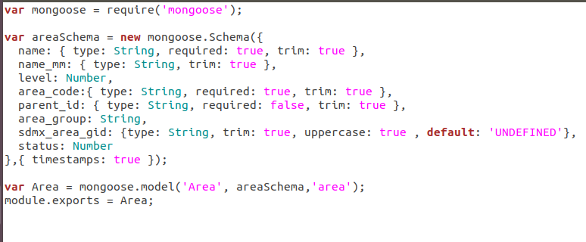**Manage Areas**

**Manage Indicators**

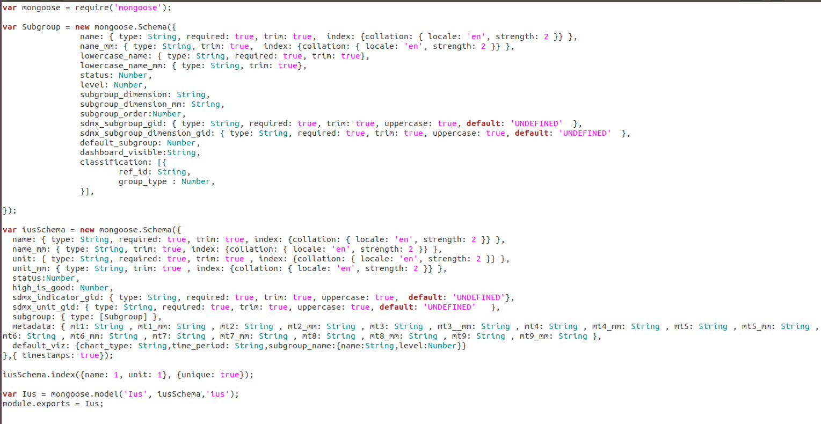

**Manage Indicators Mapping**

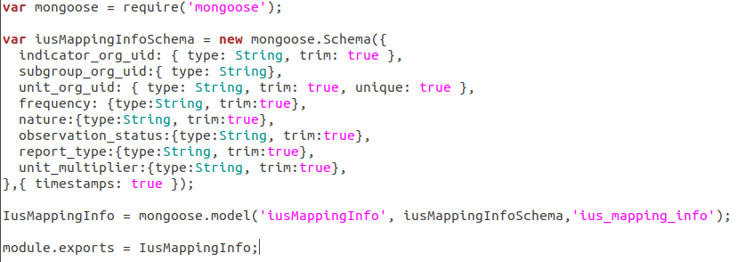

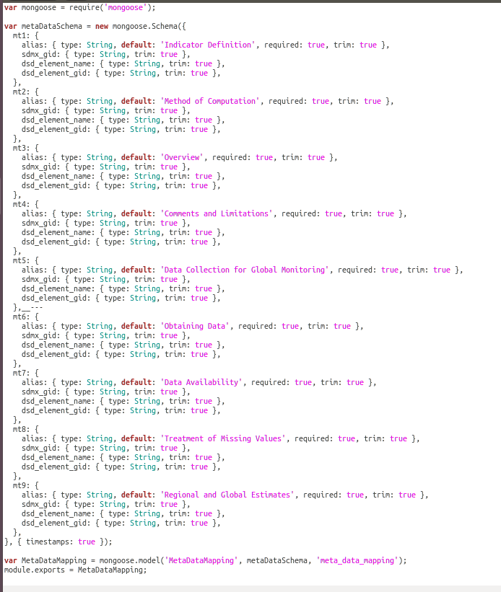**Manage Metadata**

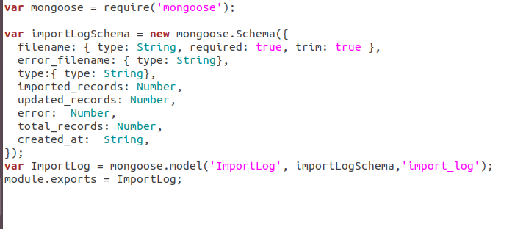**Data Import**

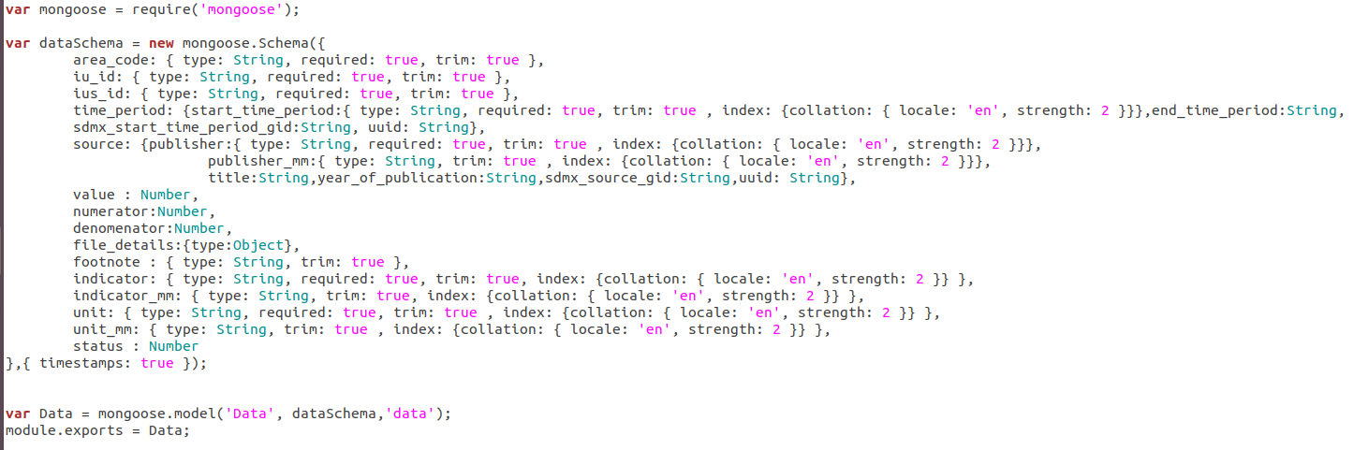**Manage Data**

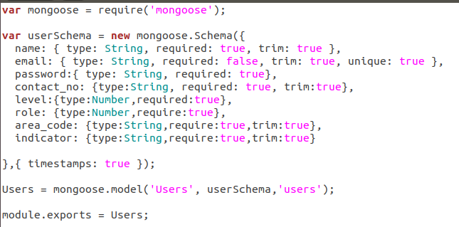 **Manage Users**

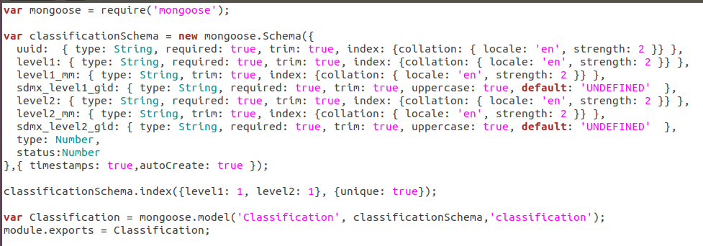**Indicator Classification**

# Annexure B: Data Flow Diagrams (DFD)

## Level 0

## Level 1: User Interface Application

## Level 2: Core Application

# Annexure C: System Architecture

# Annexure D: Software Architecture

# Annexure E: System Flow Charts

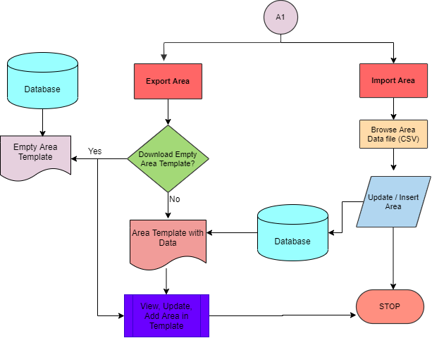**Manage Area**

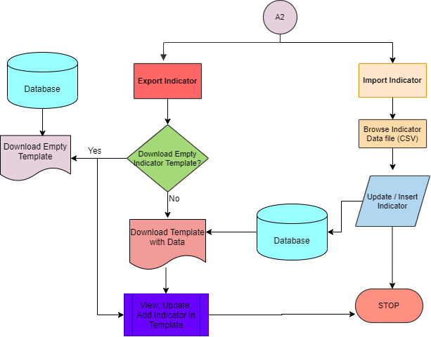**Manage Indicator**

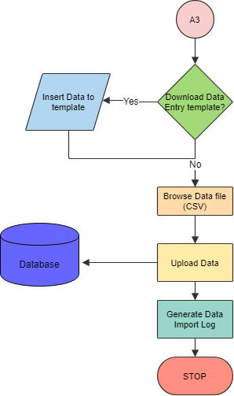**Manage Metadata**

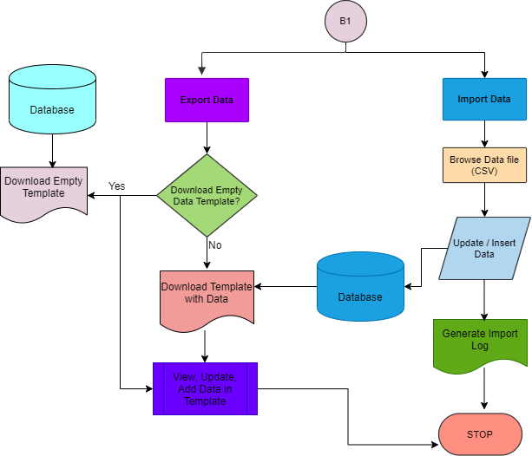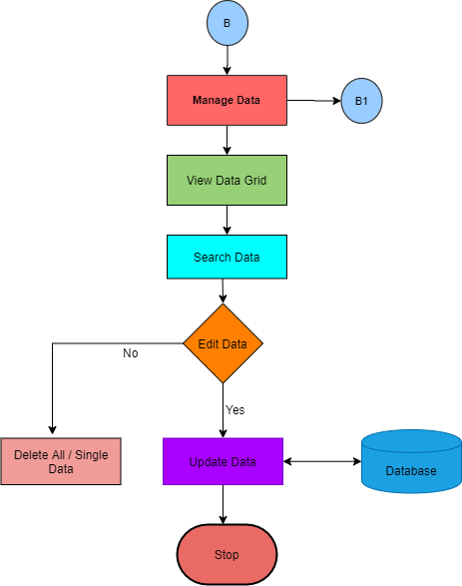**Data Entry/Edit**

--- End of the Document ----